Teach me, my God and King AMNS 240 Melody: Sandys S.M.
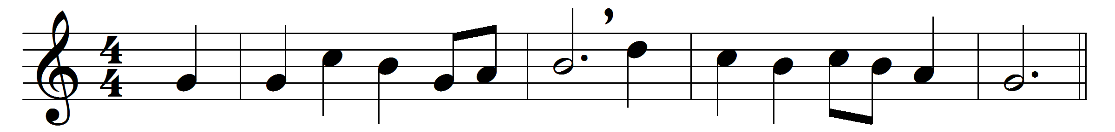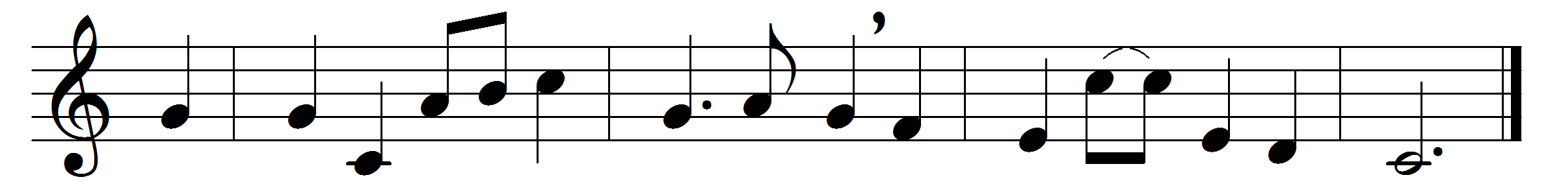

Teach me, my God and King,
in all things thee to see;
and what I do in anything
to do it as for thee.
A man that looks on glass,
on it may stay his eye;
or, if he pleaseth, through it pass,
and then the heaven espy.
All may of thee partake;
nothing can be so mean
which, with this tincture, For thy sake,
will not grow bright and clean.
A servant with this clause
makes drudgery divine;
who sweeps a room, as for thy laws,
makes that and the action fine.
This is the famous stone
that turneth all to gold;
for that which God doth touch and own
cannot for less be told.

Words: George Herbert (1593-1632)
Music: Melody from William Sandys’ Christmas Carols (1833)

