Take up thy cross, the Saviour said AMNS 237 Melody: Breslau L.M.
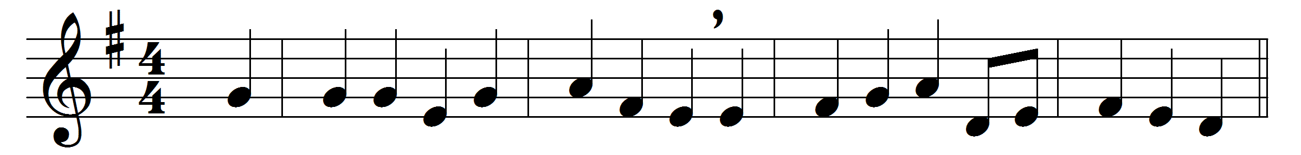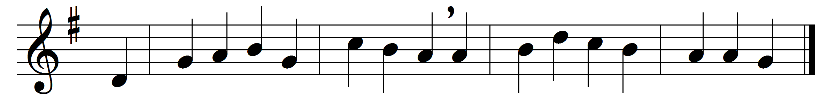

Take up thy cross, the Saviour said,
if thou wouldst my disciple be;
deny thyself, the world forsake,
and humbly follow after me.
Take up thy cross – let not its weight
fill thy weak spirit with alarm:
his strength shall bear thy spirit up,
and brace thy heart, and nerve thine arm.
Take up thy cross, nor heed the shame,
nor let thy foolish pride rebel:
thy Lord for thee the Cross endured,
to save thy soul from death and hell.
Take up thy cross then in his strength,
and calmly every danger brave;
’twill guide thee to a better home,
and lead to victory o’er the grave.
Take up thy cross, and follow Christ,
nor think till death to lay it down;
for only he who bears the cross
may hope to wear the glorious crown.
To thee, great Lord, the One in Three,
all praise for evermore ascend:
O grant us in our home to see
the heavenly life that knows no end.

Words: Charles William Everest (1814-1877)
Music: German traditional melody as used by Felix Mendelssohn-Bartholdy (1809-1847)

