Thine for ever! God of love AMNS 234 Melody: Newington 7 7. 7 7.
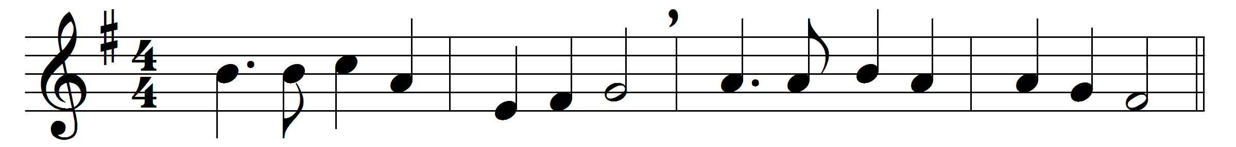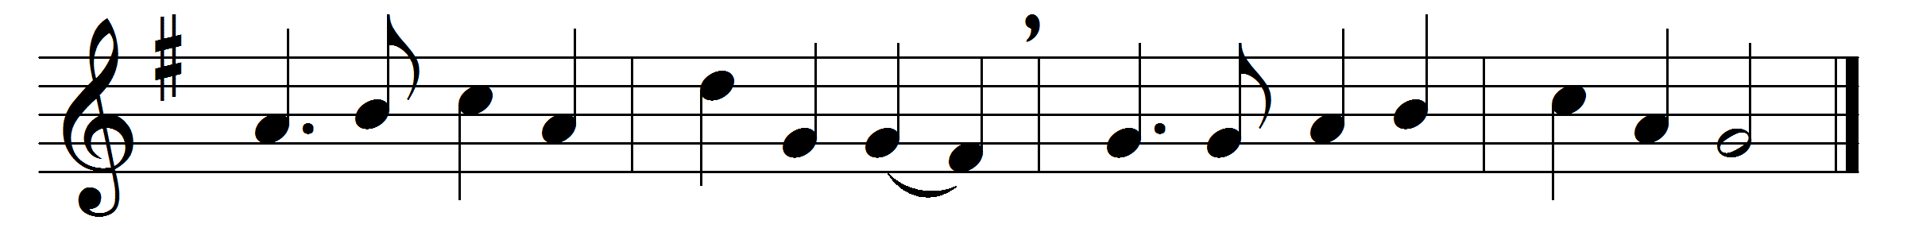

Thine for ever! God of love,
hear us from thy throne above;
thine for ever may we be
here and in eternity.

Thine for ever! Lord of life,
shield us through our earthly strife;
thou the Life, the Truth, the Way,
guide us to the realms of day.

Thine for ever! O how blest
they who find in thee their rest!
Saviour, guardian, heavenly friend,
O defend us to the end.

Thine for ever! Shepherd, keep
us thy frail and trembling sheep;
safe alone beneath thy care,
let us all thy goodness share.

Thine for ever! thou our guide,
all our wants by thee supplied,
all our sins by thee forgiven,
lead us, Lord, from earth to heaven.

Words: Mary Fawler Maude (1819-1913)
Music: William Dalrymple Maclagan (1826-1910)

