O for a heart to praise my God AMNS 230 Melody: Stockton (version in AMR) C.M.
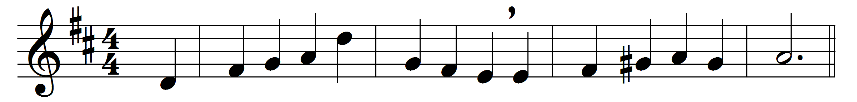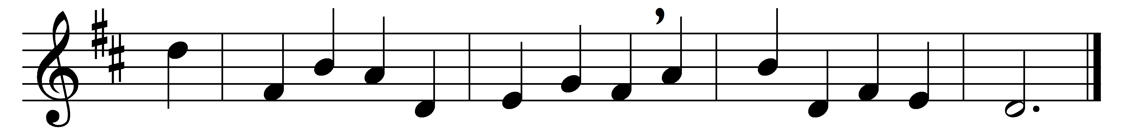

O for a heart to praise my God,
a heart from sin set free;
a heart that’s sprinkled with the blood
so freely shed for me:
a heart resigned, submissive, meek,
my great Redeemer’s throne;
where only Christ is heard to speak,
where Jesus reigns alone:
a humble, lowly, contrite heart,
believing, true, and clean,
which neither life nor death can part
from him that dwells within:
a heart in every thought renewed,
and full of love divine;
perfect and right and pure and good –
a copy, Lord, of thine.
Thy nature, gracious Lord, impart,
come quickly from above;
write thy new name upon my heart,
thy new best name of love.

Words: Charles Wesley (1707-1788)
Music: Thomas Wright (1763-1829)

