Put thou thy trust in God AMNS 223 Melody: Doncaster S.M.
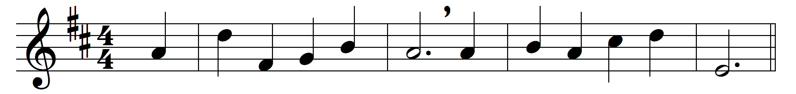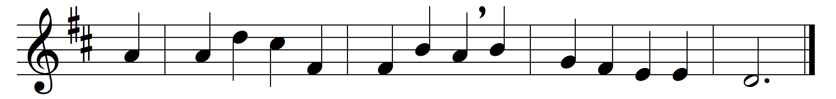

Put thou thy trust in God,
in duty’s path go on;
walk in his strength with faith and hope,
so shall thy work be done.

Commit thy ways to him,
thy works into his hands,
and rest on his unchanging word,
who heaven and earth commands.

Though years on years roll on,
his covenant shall endure;
though clouds and darkness hide his path,
the promised grace is sure.

Give to the winds thy fears;
hope, and be undismayed:
God hears thy sighs and counts thy tears;
God shall lift up thy head.

Through waves and clouds and storms
his power will clear thy way:
wait thou his time; the darkest night
shall end in brightest day.

Leave to his sovereign sway
to choose and to command;
so shalt thou, wondering, own his way,
how wise, how strong his hand.

Words: Paul Gerhardt (1607-1676), translated by John Wesley (1703-1791) and others
Music: Samuel Wesley (1766-1837)

