O God of truth, whose living word AMNS 222 Melody: Dundee C.M.
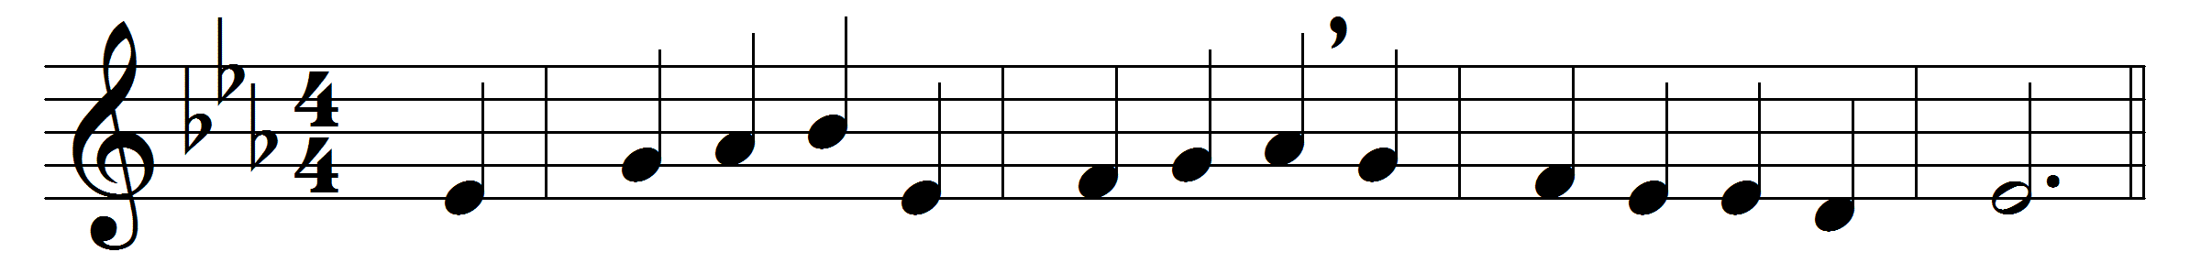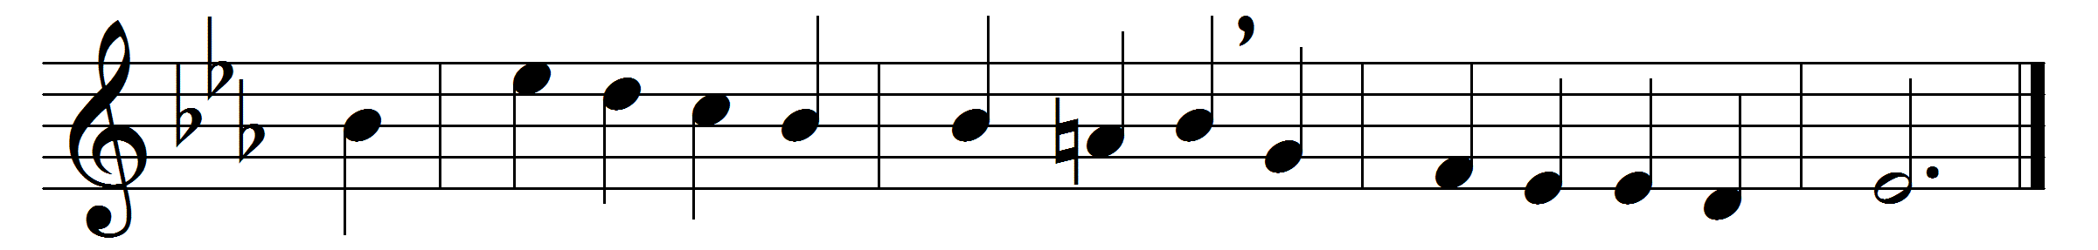

O God of truth, whose living word
upholds whate’er hath breath,
look down on thy creation, Lord,
enslaved by sin and death.
Set up thy standard, Lord, that we
who claim a heavenly birth
may march with thee to smite the lies
that vex thy groaning earth.
Ah, would we join that blest array,
and follow in the might
of him, the Faithful and the True,
in raiment clean and white?
We fight for truth? we fight for God?
poor slaves of lies and sin!
he who would fight for thee on earth
must first be true within.
Then, God of truth, for whom we long,
thou who wilt hear our prayer,
do thine own battle in our hearts,
and slay the falsehood there.
Yea, come! then, tried as in the fire,
from every lie set free,
thy perfect truth shall dwell in us,
and we shall live in thee.

Words: Thomas Hughes (1822-1896)
Music: Melody from Psalms (Edinburgh, 1615)

