Stand up, stand up for Jesus AMNS 221 Melody: Morning Light 7 6. 7 6. D.
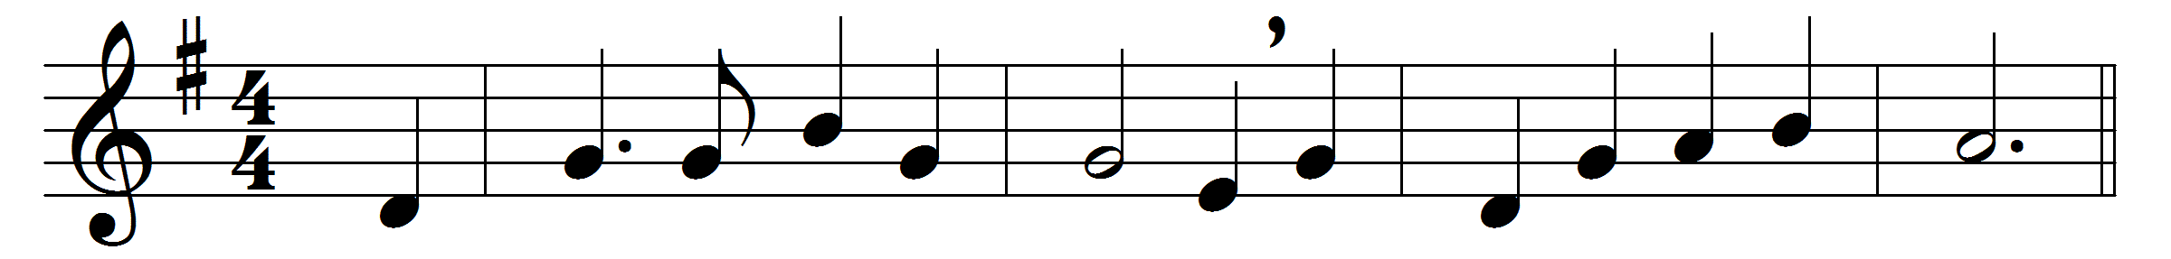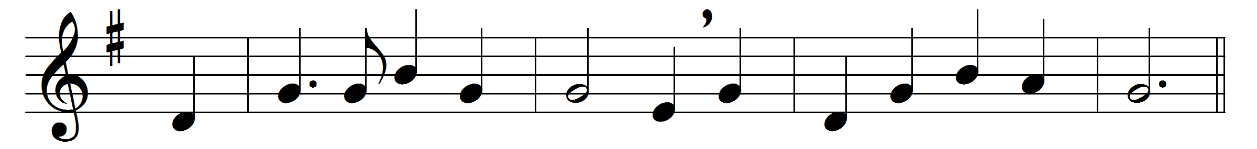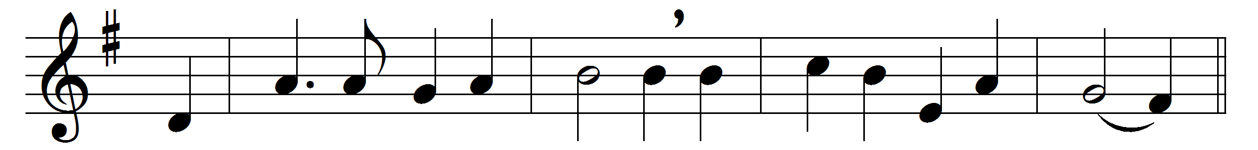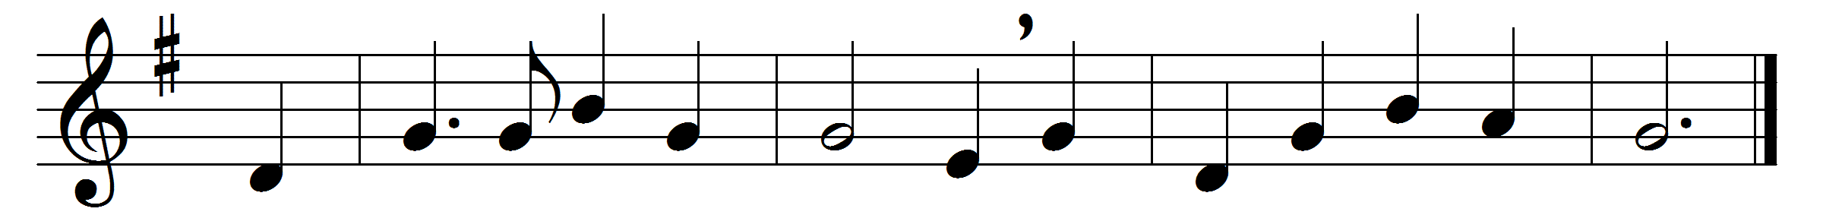

Stand up, stand up for Jesus,
ye soldiers of the Cross!
lift high his royal banner,
it must not suffer loss.
From victory unto victory
his army he shall lead,
till every foe is vanquished,
and Christ is Lord indeed.
Stand up, stand up for Jesus,
the solemn watchword hear;
if while ye sleep he suffers,
away with shame and fear.
Where’er ye meet with evil,
within you or without,
charge for the God of battles,
and put the foe to rout.

Stand up, stand up for Jesus,
the trumpet call obey;
forth to the mighty conflict
in this his glorious day.
Ye that are men now serve him
against unnumbered foes;
let courage rise with danger
and strength to strength oppose.
Stand up, stand up for Jesus,
stand in his strength alone;
the arm of flesh will fail you,
ye dare not trust your own.
Put on the Gospel armour,
each piece put on with prayer;
when duty calls or danger
be never wanting there.
Stand up, stand up for Jesus,
the strife will not be long;
this day the noise of battle,
the next the victor’s song.
To him that overcometh
a crown of life shall be;
he with the King of Glory
shall reign eternally.

Words: George Duffield (1818-1888)
Music: George James Webb (1803-1887)

