Soldiers of Christ, arise AMNS 219 Melody: St. Ethelwald S.M.
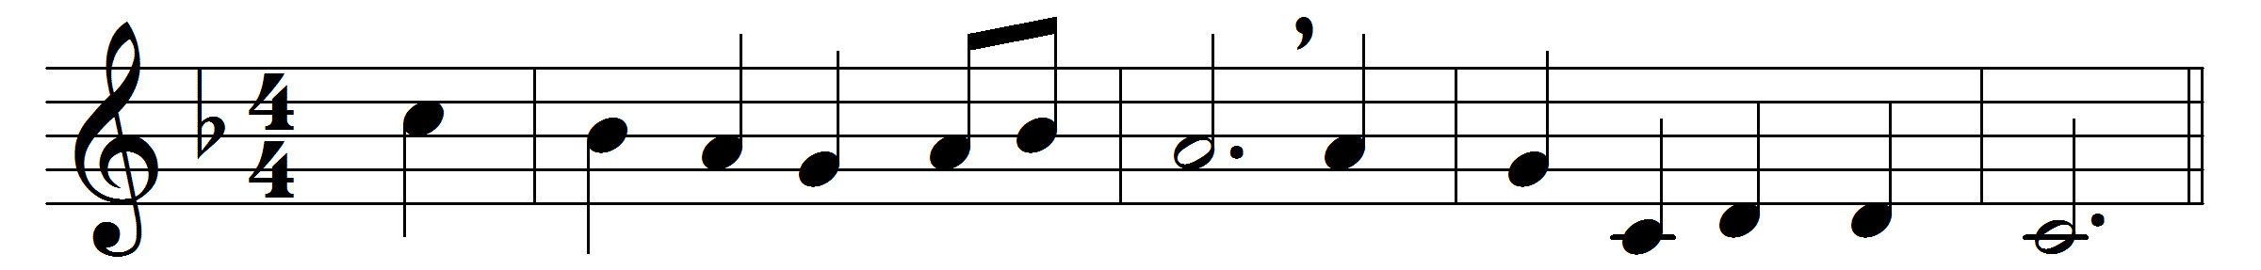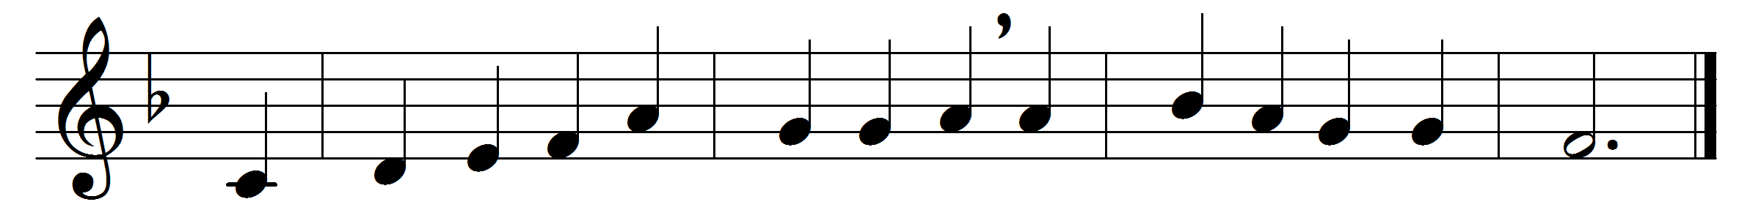

Soldiers of Christ, arise,
and put your armour on,
strong in the strength which God supplies,
through his eternal Son;
strong in the Lord of Hosts,
and in his mighty power:
who in the strength of Jesus trusts
is more than conqueror.
Stand then in his great might,
with all his strength endued;
and take, to arm you for the fight,
the panoply of God.
From strength to strength go on,
wrestle and fight and pray;
tread all the powers of darkness down,
and win the well-fought day;
that, having all things done,
and all your conflicts past,
ye may o’ercome, through Christ alone,
and stand entire at last.
Words: Charles Wesley (1707-1788)
Music: William Henry Monk (1823-1889)

