Be thou my guardian and my guide AMNS 217 Melody: Abridge C.M.
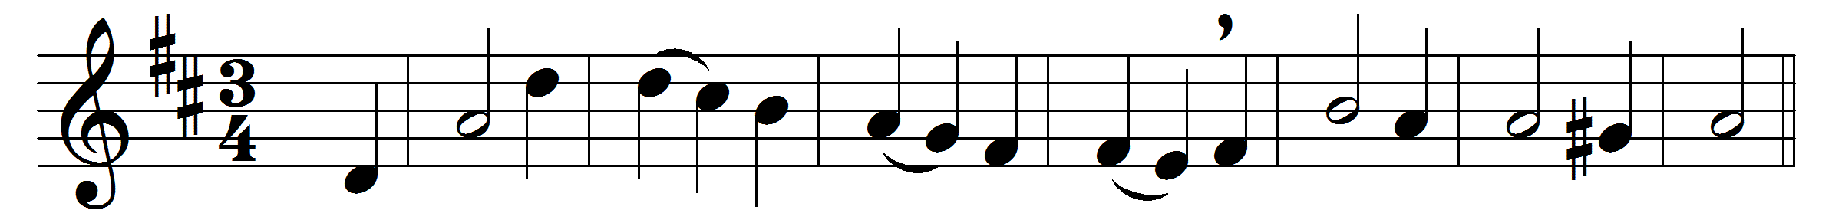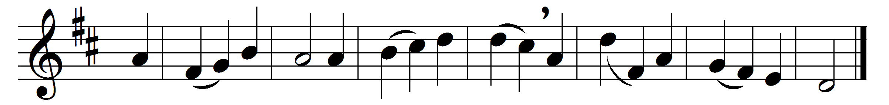

Be thou my guardian and my guide,
and hear me when I call;
let not my slippery footsteps slide,
and hold me lest I fall.

The world, the flesh, and Satan dwell
around the path I tread;
O save me from the snares of hell,
thou quickener of the dead.

And if I tempted am to sin,
and outward things are strong,
do thou, O Lord, keep watch within,
and save my soul from wrong.

Still let me ever watch and pray,
and feel that I am frail;
that if the tempter cross my way,
yet he may not prevail.

Words: Isaac Williams (1802-1865)
Music: Melody by Isaac Smith (1734-1805)

