Lead, kindly Light AMNS 215 Melody: Lux benigna 10 4. 10 4. 10 10.
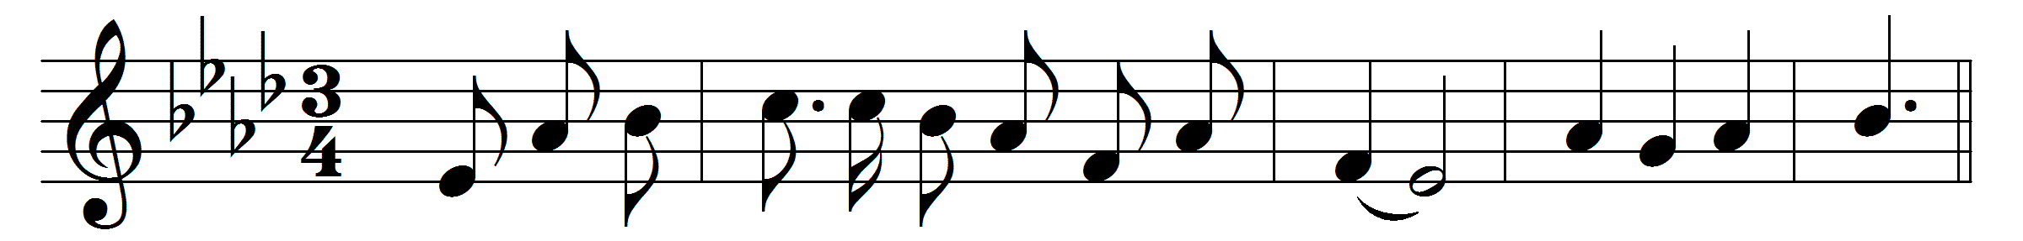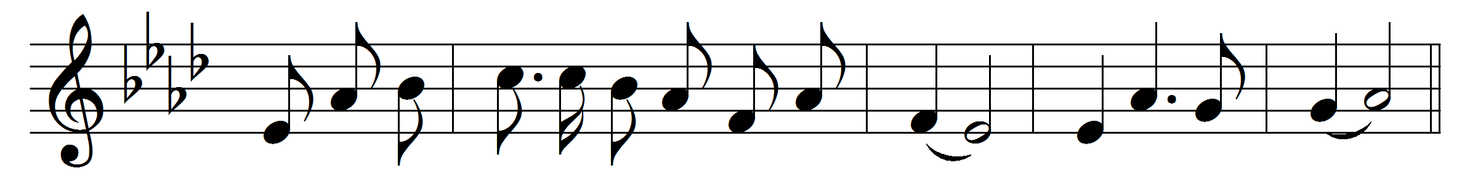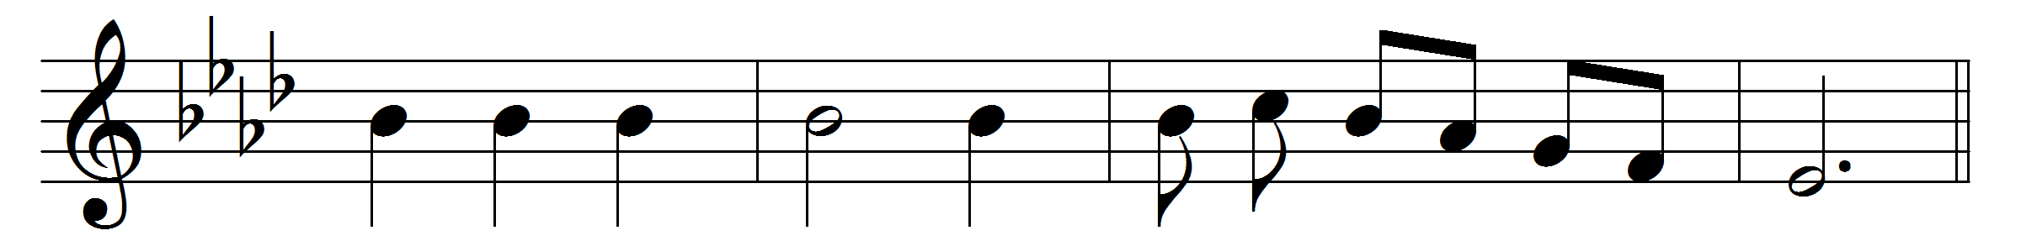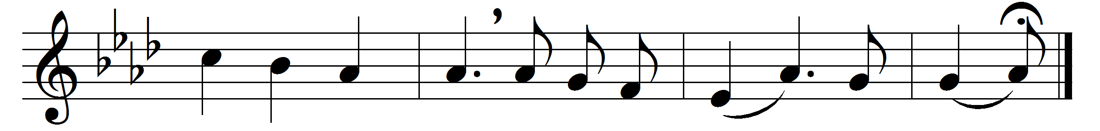

Lead, kindly Light, amid the encircling gloom,
lead thou me on;
the night is dark, and I am far from home;
lead thou me on.
Keep thou my feet; I do not ask to see
the distant scene; one step enough for me.
I was not ever thus, nor prayed that thou
shouldst lead me on;
I loved to choose and see my path; but now
lead thou me on.
I loved the garish day, and, spite of fears,
pride ruled my will: remember not past years.
So long thy power hath blest me, sure it still
will lead me on,
o’er moor and fen, o’er crag and torrent, till
the night is gone,
and with the morn those angel faces smile,
which I have loved long since, and lost awhile.

Words: John Henry Newman (1801-1890)
Music: John Bacchus Dykes (1823-1876)

