Guide me, O thou great Redeemer AMNS 214 Melody: Cwm Rhondda 8 7. 8 7. 4 7.
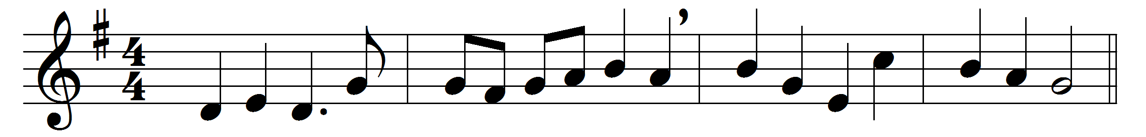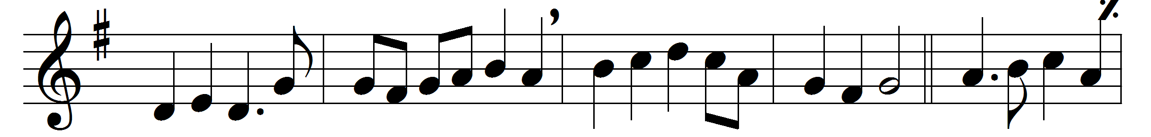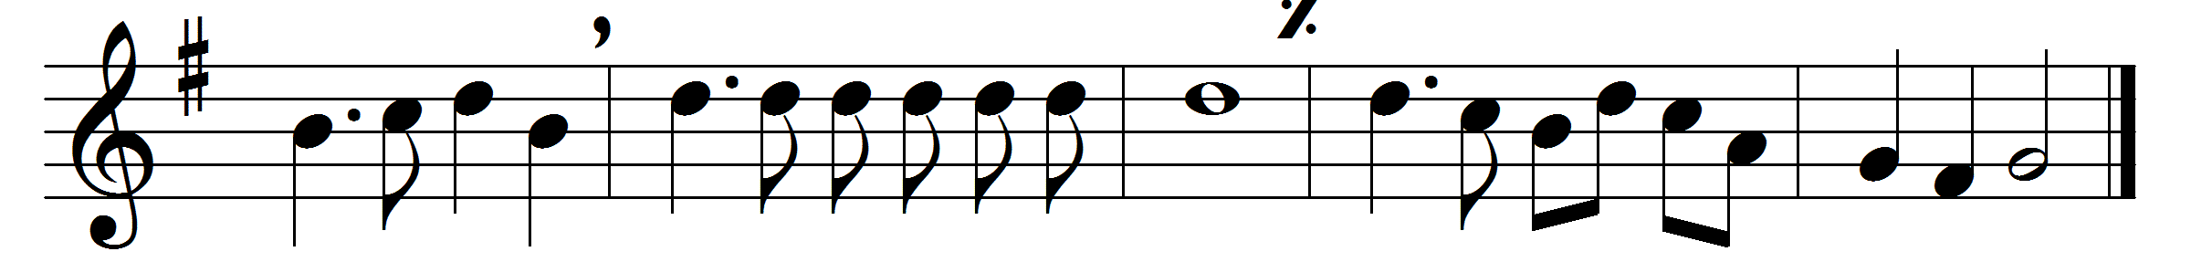

Guide me, O thou great Redeemer,
pilgrim through this barren land;
I am weak, but thou art mighty;
hold me with thy powerful hand:
bread of heaven,
feed me now and evermore.
Open now the crystal fountain
whence the healing stream doth flow;
let the fiery cloudy pillar
lead me all my journey through:
strong deliverer,
be thou still my strength and shield.
When I tread the verge of Jordan,
bid my anxious fears subside;
death of death, and hell’s destruction,
land me safe on Canaan’s side:
songs and praises
I will ever give to thee.

Words: William Williams (1717-1791), translated by Peter Williams (1723-1796)
Music: John Hughes (1873-1932)

