Oft in danger, oft in woe AMNS 210 Melody: University College 7 7. 7 7.
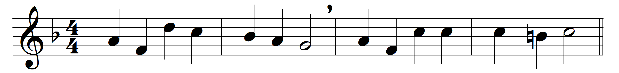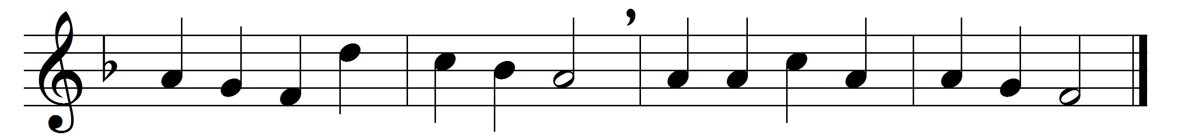

Oft in danger, oft in woe,
onward, Christians, onward go;
bear the toil, maintain the strife,
strengthened with the bread of life.

Onward, Christians, onward go,
join the war, and face the foe;
will ye flee in danger’s hour?
know ye not your Captain’s power?

Let not sorrow dim your eye;
soon shall every tear be dry:
let not fears your course impede;
great your strength, if great your need.

Let your drooping hearts be glad;
march in heavenly armour clad;
fight, nor think the battle long:
soon shall victory wake your song.

Onward then in battle move;
more than conquerors ye shall prove:
though opposed by many a foe,
Christian soldiers, onward go.

Words: Henry Kirke White (1785-1806) and others
Music: Henry John Gauntlett (1805-1876)

