Again the Lord’s own day is here AMNS 20 Melody: Church Triumphant L.M.
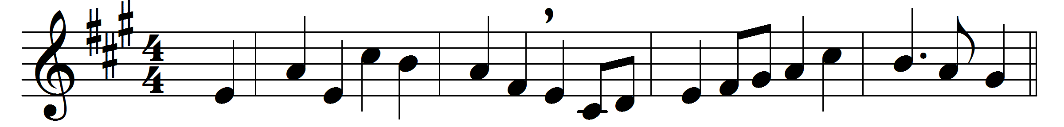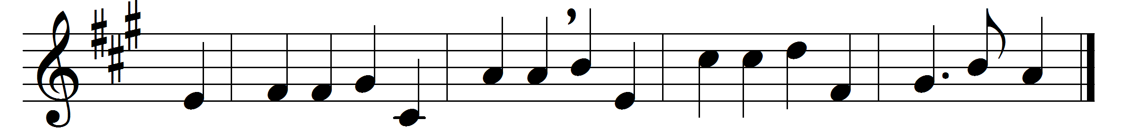

Again the Lord’s own day is here,
the day to Christian people dear,
as, week by week, it bids them tell
how Jesus rose from death and hell.
For by his flock their Lord declared
his resurrection should be shared;
and we who trust in him to save
with him are risen from the grave.
We, one and all, of him possessed,
are with exceeding treasures blessed;
for all he did, and all he bare,
he gives us as our own to share.
Eternal glory, rest on high,
a blessèd immortality,
true peace and gladness, and a throne,
are all his gifts, and all our own.
And therefore unto thee we sing,
O Lord of peace, eternal King;
thy love we praise, thy name adore,
both on this day and evermore.

Words: Ascribed to Thomas à Kempis (c. 1380-1471), translated by John Mason Neale (1818-1866)
Music: James William Elliott (1833-1915)

