Through all the changing scenes of life AMNS 209 Melody: Wiltshire C. M.
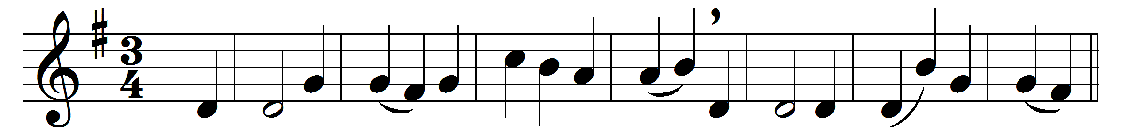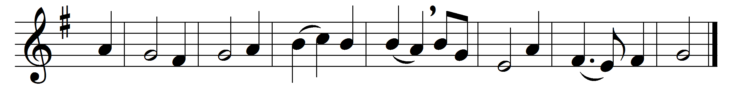

Through all the changing scenes of life,
in trouble and in joy,
the praises of my God shall still
my heart and tongue employ.
O magnify the Lord with me,
with me exalt his name;
when in distress to him I called,
he to my rescue came.
The hosts of God encamp around
the dwellings of the just;
deliverance he affords to all
who on his succour trust.
O make but trial of his love:
experience will decide
how blest are they, and only they,
who in his truth confide.
Fear him, ye saints, and you will then
have nothing else to fear;
make you his service your delight,
your wants shall be his care.

To Father, Son, and Holy Ghost,
the God whom we adore,
be glory, as it was, is now,
and shall be evermore.

Words: Psalm 34 in New Version (Tate and Brady, 1696)
Music: George Thomas Smart (1776-1867)

