O happy band of pilgrims AMNS 208 Melody: Kocher 7 6. 7 6.
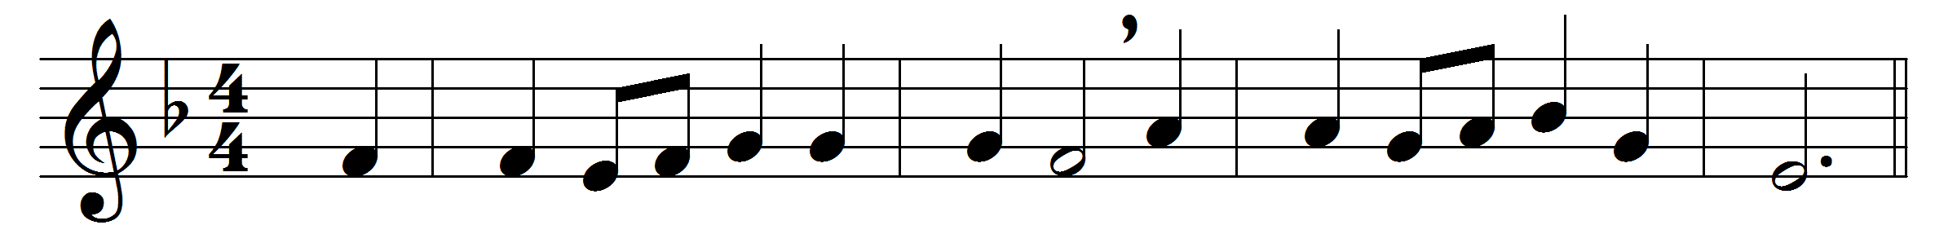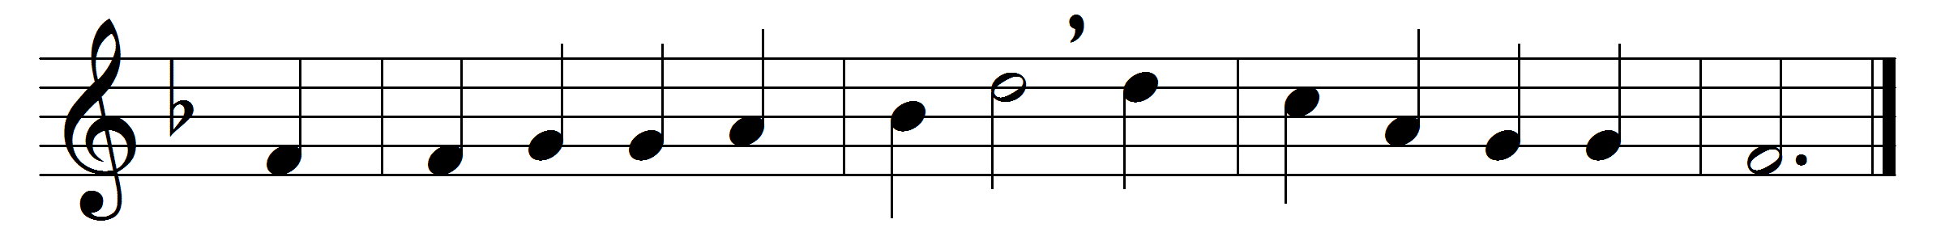

O happy band of pilgrims,
if onward ye will tread
with Jesus as your fellow
to Jesus as your Head.
O happy if ye labour
as Jesus did for men;
O happy if ye hunger
as Jesus hungered then.
The cross that Jesus carried
he carried as your due:
the crown that Jesus weareth
he weareth it for you.

The faith by which ye see him,
the hope in which ye yearn,
the love that through all troubles
to him alone will turn,
the trials that beset you,
the sorrows ye endure,
the manifold temptations
that death alone can cure,
what are they but his jewels
of right celestial worth?
what are they but the ladder
set up to heaven on earth?
O happy band of pilgrims,
look upward to the skies,
where such a light affliction
shall win so great a prize.

Words: St. Joseph the Hymnographer (c. 810-c. 886), translated by John Mason Neale (1818-1866)
Music: Justin Heinrich Knecht (1752-1817)

