Praise to the Lord, the Almighty, the King of creation
AMNS 207 Melody: Lobe den Herren 14 14. 4 7. 8.
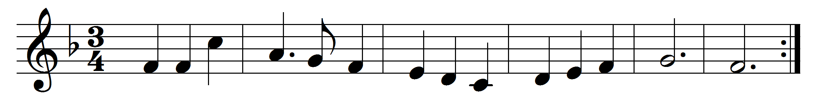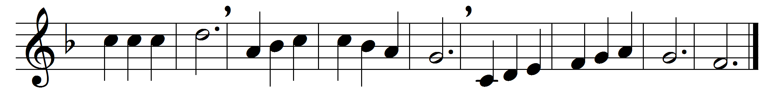

Praise to the Lord, the Almighty, the King of creation;
O my soul, praise him, for he is thy health and salvation:
all ye who hear,
now to his temple draw near,
joining in glad adoration.
Praise to the Lord, who o’er all things so wondrously reigneth,
shieldeth thee gently from harm, or when fainting sustaineth:
hast thou not seen
how thy heart’s wishes have been
granted in what he ordaineth?
Praise to the Lord, who doth prosper thy work and defend thee;
surely his goodness and mercy shall daily attend thee:
ponder anew
what the Almighty can do,
if to the end he befriend thee.
Praise to the Lord! O let all that is in me adore him!
All that hath life and breath, come now with praises before him!
let the Amen
sound from his people again:
gladly for ay we adore him.

Words: Joachim Neander (1650-1680), translated by Catherine Winkworth (1827-1878)
Music: Melody from Praxis Pietatis Melica (1668)

