O praise ye the Lord! AMNS 203 Melody: Laudate Dominum (Parry) 10 10. 11 11.
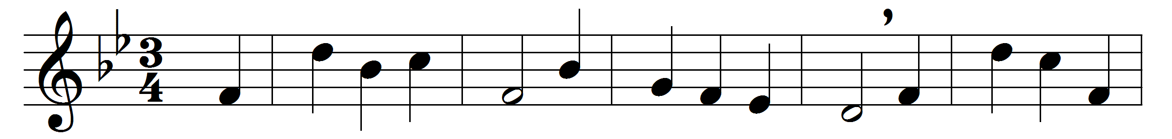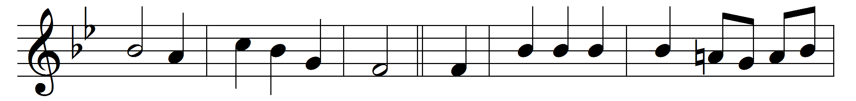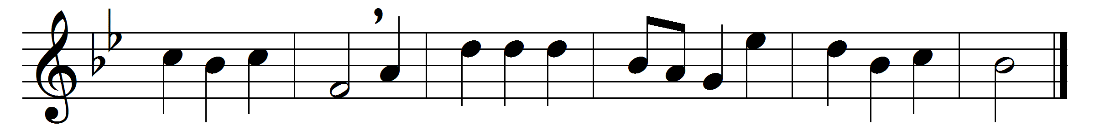

O praise ye the Lord! praise him in the height;
rejoice in his word, ye angels of light;
ye heavens adore him by whom ye were made,
and worship before him, in brightness arrayed.

O praise ye the Lord! praise him upon earth,
in tuneful accord, ye sons of new birth;
praise him who hath brought you his grace from above,
praise him who hath taught you to sing of his love.

O praise ye the Lord, all things that give sound;
each jubilant chord re-echo around;
loud organs, his glory forth tell in deep tone,
and, sweet harp, the story of what he hath done.

O praise ye the Lord! thanksgiving and song
to him be outpoured all ages along:
for love in creation, for heaven restored,
for grace of salvation, O praise ye the Lord!

Words: Henry Williams Baker (1821-1877)
Music: C. Hubert H. Parry (1848-1918)

