Awake, my soul, and with the sun AMNS 1 Melody: Morning Hymn L.M.
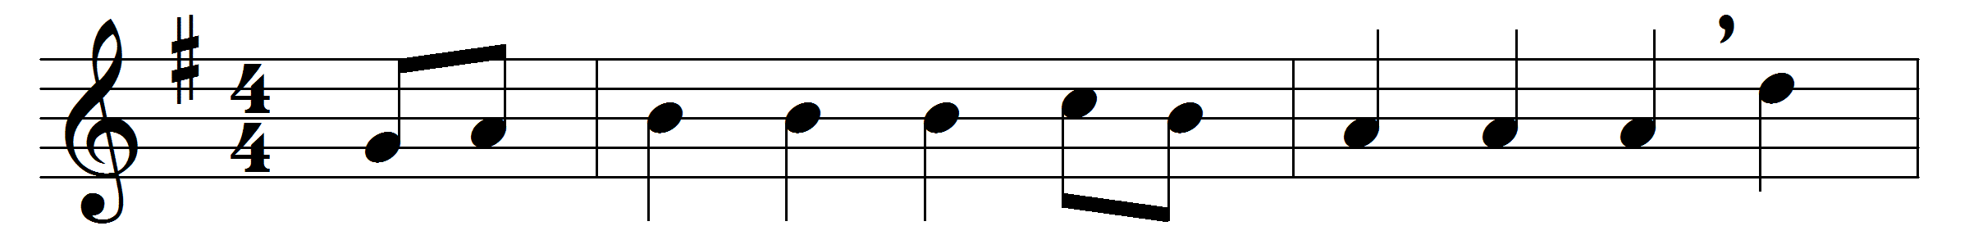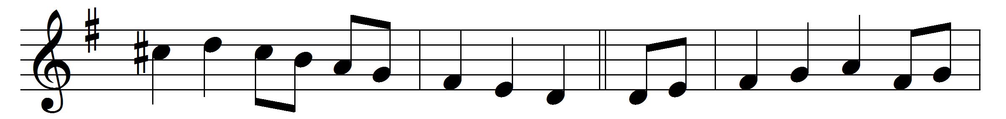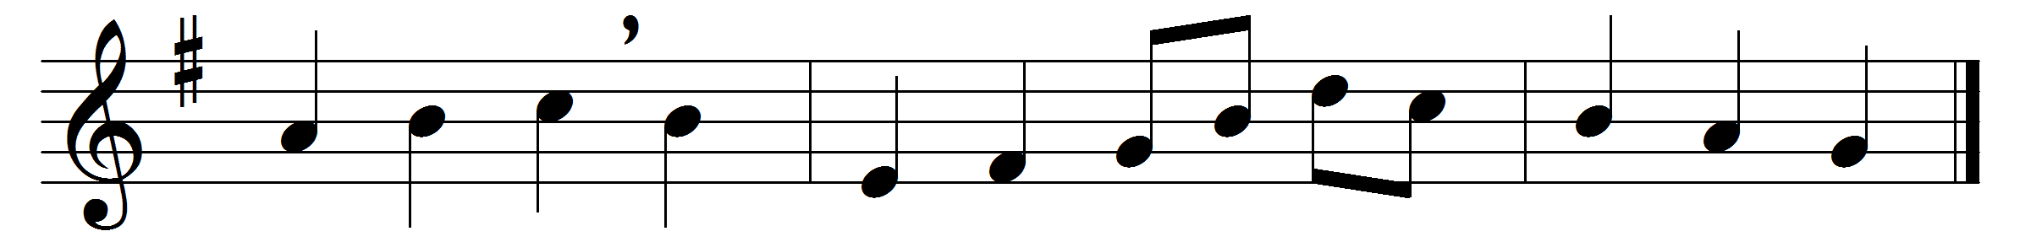

Part 1
Awake, my soul, and with the sun
thy daily stage of duty run;
shake off dull sloth, and joyful rise
to pay thy morning sacrifice.
Redeem thy mis-spent time that’s past,
and live this day as if thy last;
improve thy talent with due care;
for the great day thyself prepare.
Let all thy converse be sincere,
thy conscience as the noon-day clear;
think how all-seeing God thy ways
and all thy secret thoughts surveys.
Wake, and lift up thyself, my heart,
and with the angels bear thy part,
who all night long unwearied sing
high praise to the eternal King.
Part 2
Glory to thee, who safe hast kept
and hast refreshed me whilst I slept;
grant, Lord, when I from death shall wake,
I may of endless light partake.
Lord, I my vows to thee renew;
disperse my sins as morning dew;
guard my first springs of thought and will,
and with thyself my spirit fill.
Direct, control, suggest, this day,
all I design or do or say;
that all my powers, with all their might,
in thy sole glory may unite.

Doxology
Praise God, from whom all blessings flow,
praise him, all creatures here below,
praise him above, angelic host,
praise Father, Son, and Holy Ghost.

Words: Thomas Ken (1637-1711)
Music: François Hippolyte Barthélémon (1741-1808)

