Immortal, invisible, God only wise AMNS 199 Melody: St. Denio 11 11. 11 11.
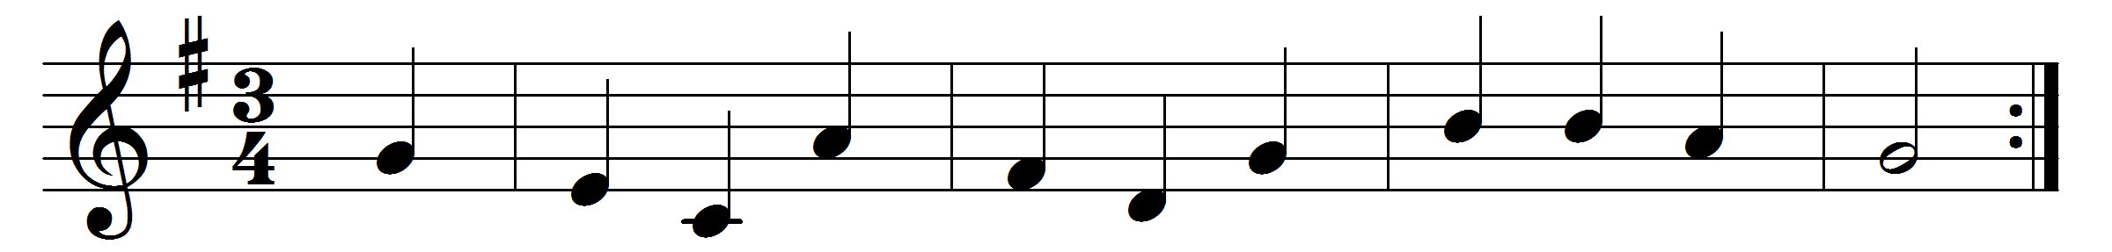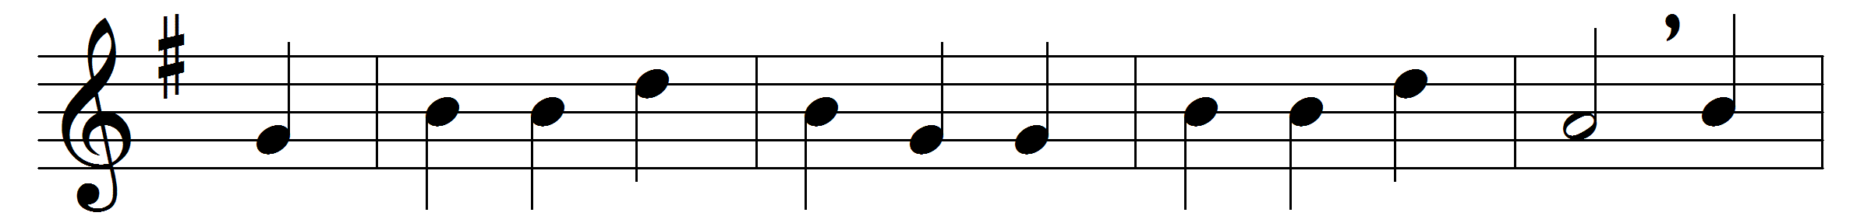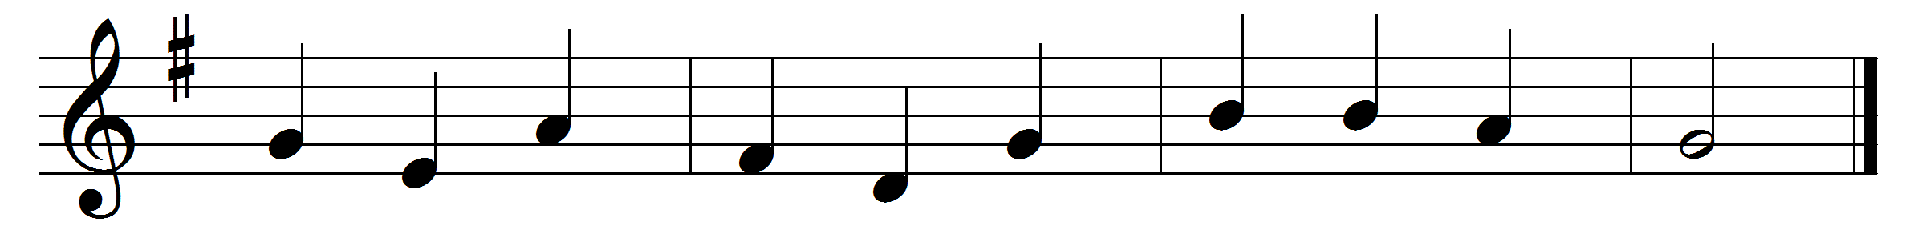

Immortal, invisible, God only wise,
in light inaccessible hid from our eyes,
most blessèd, most glorious, the Ancient of Days,
almighty, victorious, thy great name we praise.
Unresting, unhasting, and silent as light,
nor wanting, nor wasting, thou rulest in might;
thy justice like mountains high soaring above
thy clouds which are fountains of goodness and love.
To all life thou givest, to both great and small;
in all life thou livest, the true life of all;
we blossom and flourish as leaves on the tree,
and wither and perish; but naught changeth thee.
Great Father of glory, pure Father of light,
thine angels adore thee, all veiling their sight;
all laud we would render: O help us to see
’tis only the splendour of light hideth thee.

Words: Walter Chalmers Smith (1824-1908)
Music: Welsh hymn melody

