Ye holy angels bright AMNS 198 Melody: Darwall’s 148th 6 6. 6 6. 4 4. 4 4.
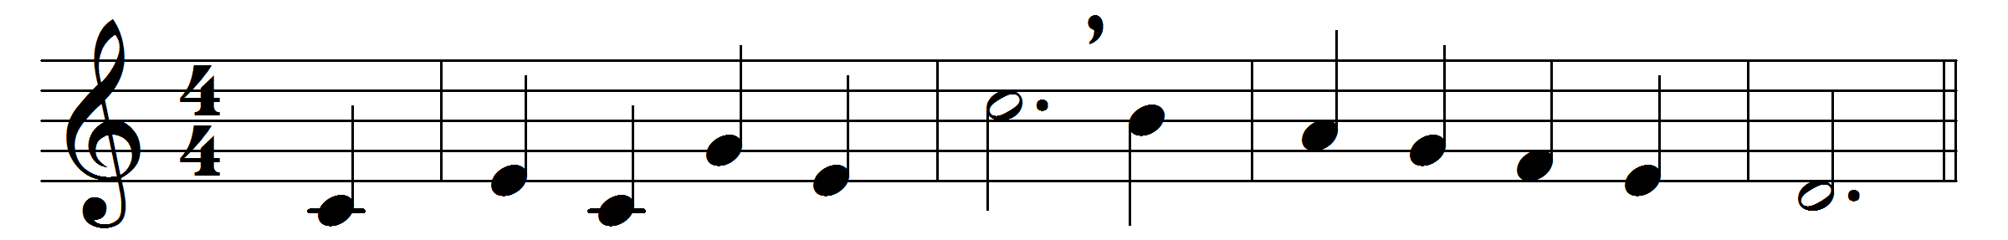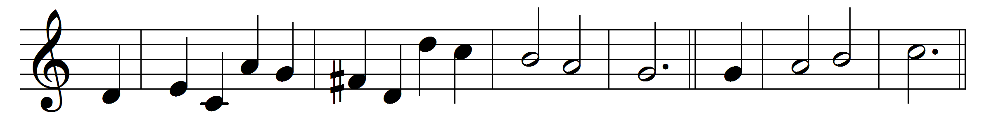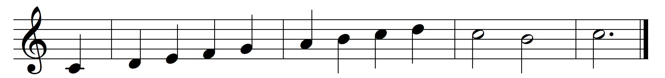

Ye holy angels bright,
who wait at God’s right hand,
or through the realms of light
fly at your Lord’s command,
assist our song,
for else the theme
too high doth seem
for mortal tongue.
Ye blessèd souls at rest,
who ran this earthly race,
and now, from sin released,
behold the Saviour’s face,
his praises sound,
as in his sight
with sweet delight
ye do abound.
Ye saints, who toil below,
adore your heavenly King,
and onward as ye go
some joyful anthem sing;
take what he gives
and praise him still,
through good and ill,
who ever lives.
My soul, bear thou thy part,
triumph in God above,
and with a well-tuned heart
sing thou the songs of love;
let all thy days
till life shall end,
whate’er he send,
be filled with praise.

Words: Richard Baxter (1615-1691) and John Hampden Gurney (1802-1862)
Music: Melody by John Darwall (1731-1789), harmony by William Henry Monk (1823-1889)

