Before Jehovah’s aweful throne AMNS 197 Melody: Old 100th L.M.
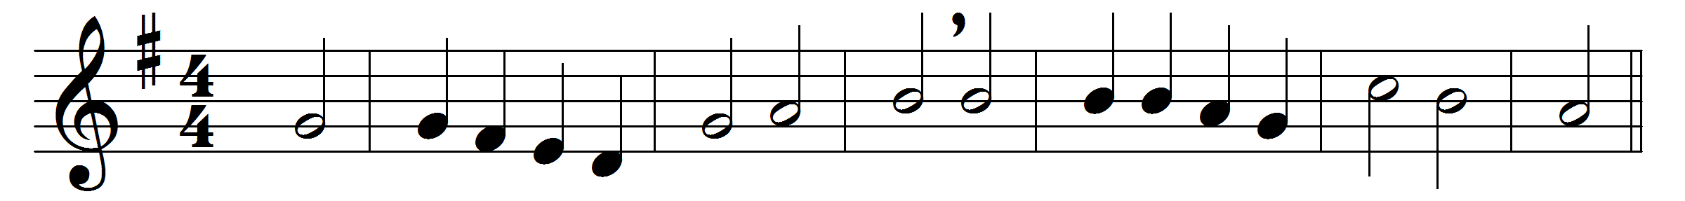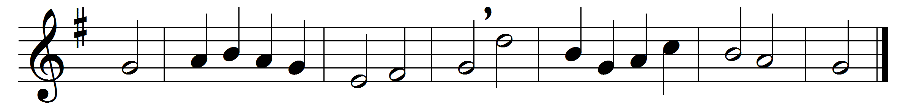

Before Jehovah’s aweful throne,
ye nations, bow with sacred joy;
know that the Lord is God alone:
he can create, and he destroy.

His sovereign power, without our aid,
made us of clay, and formed us men;
and, when like wandering sheep we strayed,
he brought us to his fold again.

We’ll crowd thy gates with thankful songs,
high as the heavens our voices raise;
and earth, with her ten thousand tongues,
shall fill thy courts with sounding praise.

Wide as the world is thy command,
vast as eternity thy love;
firm as a rock thy truth shall stand,
when rolling years shall cease to move.

Words: Isaac Watts (1674-1748)
Music: Melody in Genevan Psalter, 1551

