Praise the Lord! ye heavens, adore him AMNS 195 Melody: Austria 8 7. 8 7. D.
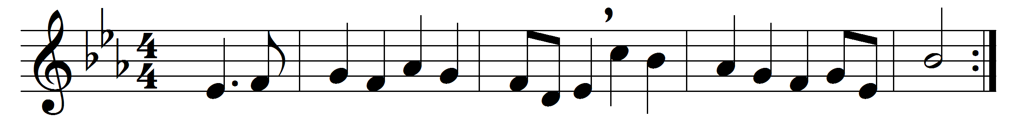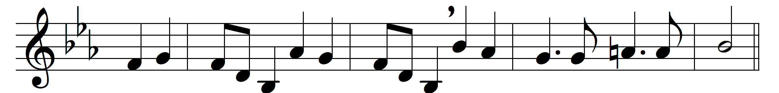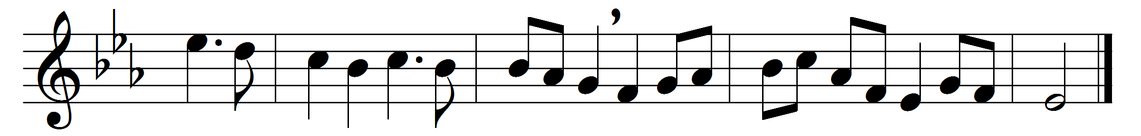

Praise the Lord! ye heavens, adore him;
praise him, angels, in the height;
sun and moon, rejoice before him,
praise him, all ye stars and light.
Praise the Lord! for he hath spoken;
worlds his mighty voice obeyed:
laws, which never shall be broken,
for their guidance he hath made.

Praise the Lord! for he is glorious;
never shall his promise fail:
God hath made his saints victorious;
sin and death shall not prevail.
Praise the God of our salvation;
hosts on high, his power proclaim;
heaven and earth and all creation,
laud and magnify his name!

Words: Foundling Hospital Collection, c. 1796
Music: Joseph Haydn (1732-1809)

