My soul, there is a country AMNS 191 Melody: Christus der ist mein Leben 7 6. 7 6.
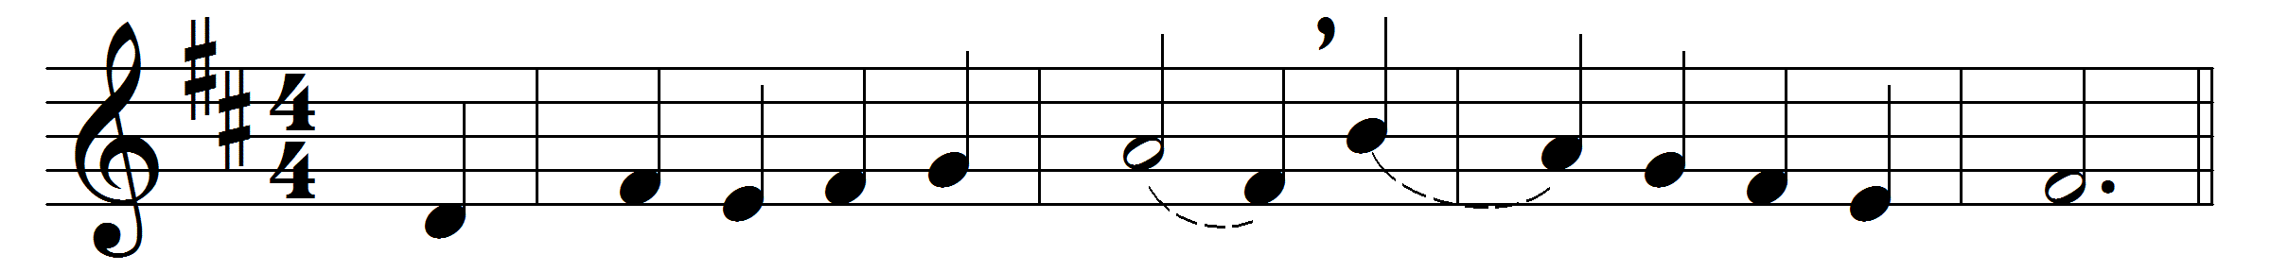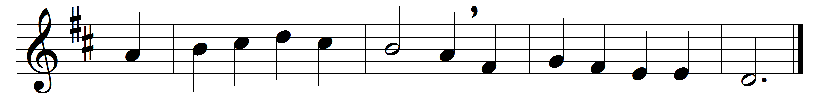

My soul, there is a country
far beyond the stars,
where stands a wingèd sentry
all skilful in the wars.

There above noise, and danger,
sweet peace sits crowned with smiles,
and One born in a manger
commands the beauteous files.

He is thy gracious Friend,
and – O my soul, awake! –
did in pure love descend,
to die here for thy sake.

If thou canst get but thither,
there grows the flower of peace,
the Rose that cannot wither,
thy fortress and thy ease.

Leave then thy foolish ranges,
for none can thee secure
but one who never changes,
thy God, thy life, thy cure.

Words: Henry Vaughan (1622-1695)
Music: Melody by Melchior Vulpius (c. 1560-1615), arranged by Johann Sebastian Bach (1685-1750)

