Ten thousand times ten thousand AMNS 189 Melody: Alford 7 6. 8 6. D.
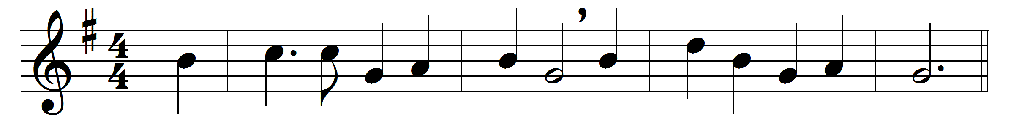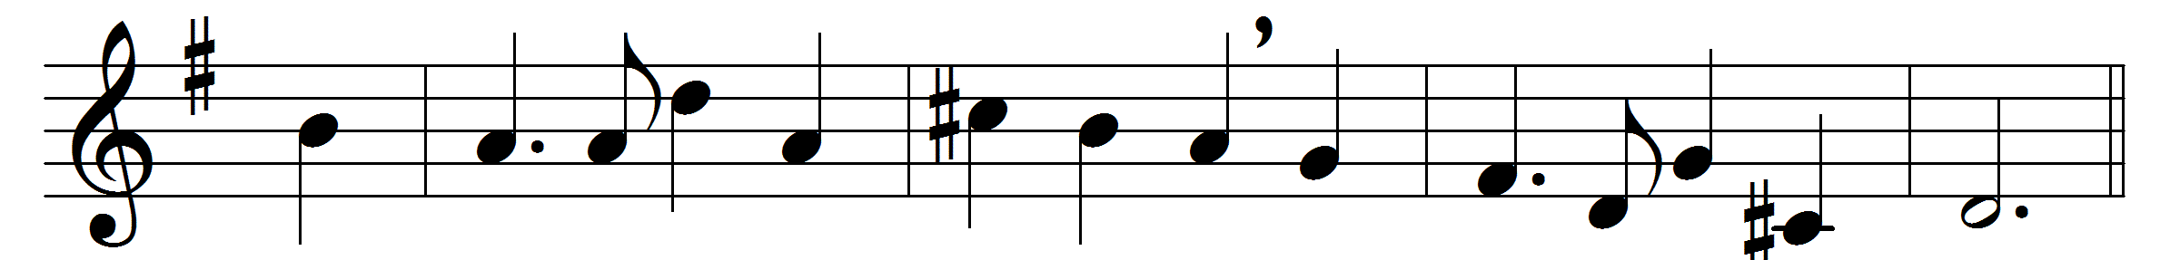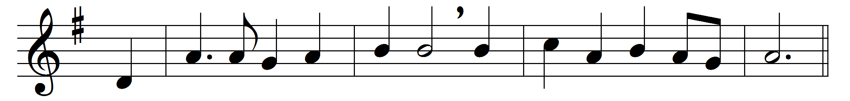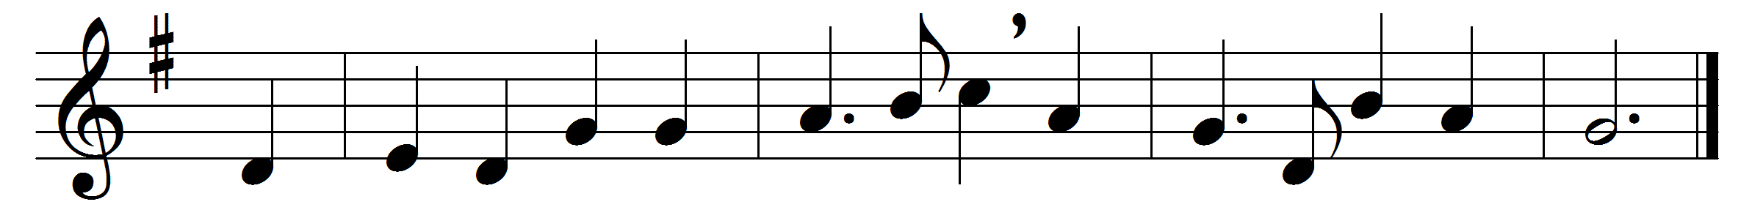

Ten thousand times ten thousand,
in sparkling raiment bright,
the armies of the ransomed saints
throng up the steeps of light:
’tis finished! all is finished,
their fight with death and sin;
fling open wide the golden gates,
and let the victors in.
What rush of alleluias
fills all the earth and sky,
what ringing of a thousand harps
bespeaks the triumph nigh!
O day, for which creation
and all its tribes were made!
O joy, for all its former woes
a thousand-fold repaid!
O then what raptured greetings
on Canaan’s happy shore,
what knitting severed friendships up,
where partings are no more!
Then eyes with joy shall sparkle
that brimmed with tears of late:
orphans no longer fatherless,
nor widows desolate.
Bring near thy great salvation,
thou Lamb for sinners slain,
fill up the roll of thine elect,
then take thy power and reign:
appear, Desire of Nations;
thine exiles long for home;
show in the heavens thy promised sign;
thou Prince and Saviour, come.

Words: Henry Alford (1810-1871)
Music: John Bacchus Dykes (1823-1876)

