Light’s abode, celestial Salem AMNS 185 Melody: Regent Square 8 7. 8 7. 8 7
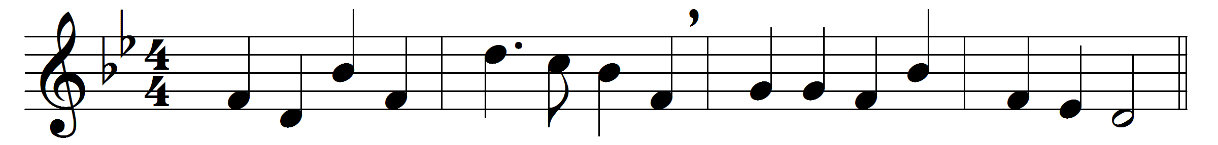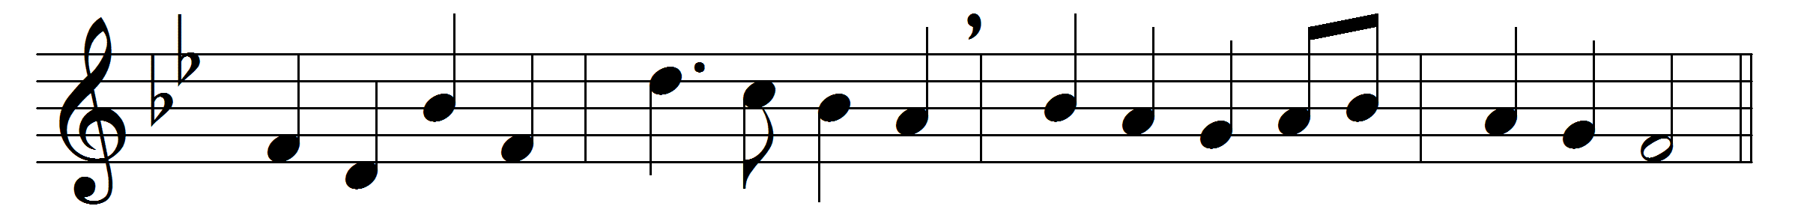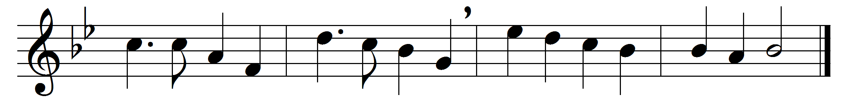

Light’s abode, celestial Salem,
vision whence true peace doth spring,
brighter than the heart can fancy,
mansion of the highest King;
O how glorious are the praises
which of thee the prophets sing!

There for ever and for ever
alleluia is outpoured;
for unending, for unbroken
is the feast-day of the Lord;
all is pure and all is holy
that within thy walls is stored.

There no cloud or passing vapour
dims the brightness of the air;
endless noon-day, glorious noon-day,
from the Sun of suns is there;
there no night brings rest from labour,
for unknown are toil and care.

O how glorious and resplendent,
fragile body, shalt thou be,
when endued with so much beauty,
full of health and strong and free,
full of vigour, full of pleasure
that shall last eternally.

Now with gladness, now with courage,
bear the burden on thee laid,
that hereafter these thy labours
may with endless gifts be paid;
and in everlasting glory
thou with brightness be arrayed.

Laud and honour to the Father,
laud and honour to the Son,
laud and honour to the Spirit,
ever Three and ever One,
consubstantial, co-eternal,
while unending ages run.

Words: Ascribed to Thomas à Kempis (c. 1380-1471), translated by John Mason Neale (1818-1866)
Music: Henry Smart (1813-1879)

