He wants not friends that hath thy love AMNS 183 Melody: Invitation (Devonshire) C.M.
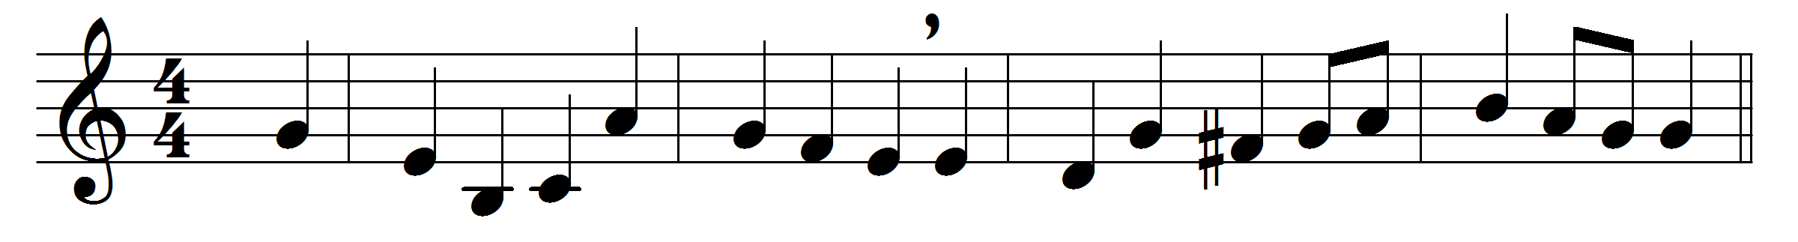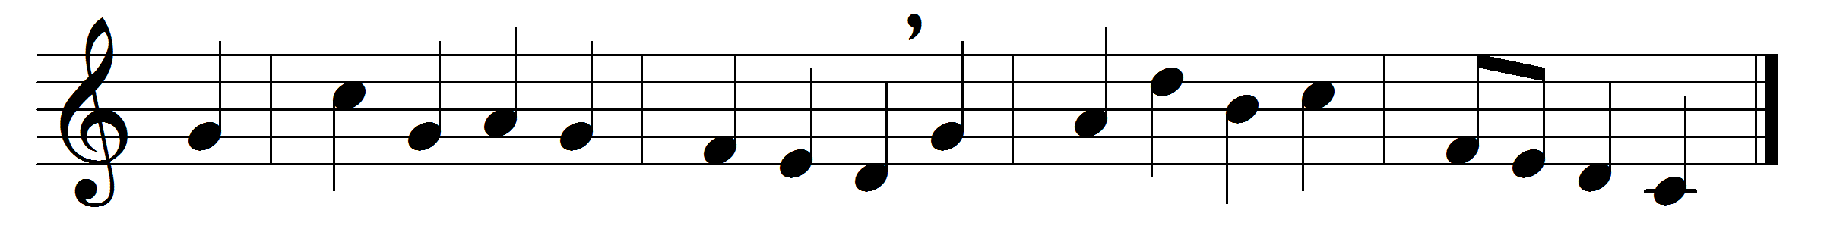

He wants not friends that hath thy love,
and may converse and walk with thee,
and with thy saints here and above,
with whom for ever I must be.
In the blest fellowship of saints
is wisdom, safety, and delight;
and when my heart declines and faints,
it’s raisèd by their heat and light.
As for my friends, they are not lost;
the several vessels of thy fleet,
though parted now, by tempests tost,
shall safely in the haven meet.
Still we are centred all in thee,
members, though distant, of one Head;
in the same family we be,
by the same faith and spirit led.
Before thy throne we daily meet
as joint-petitioners to thee;
in spirit we each other greet,
and shall again each other see.
The heavenly hosts, world without end,
shall be my company above;
and thou, my best and surest Friend,
who shall divide me from thy love?

Words: Richard Baxter (1615-1691)
Music: Melody by John Frederick Lampe (1703-1751)

