May the grace of Christ our Saviour AMNS 181 Melody: Waltham 8 7. 8 7.
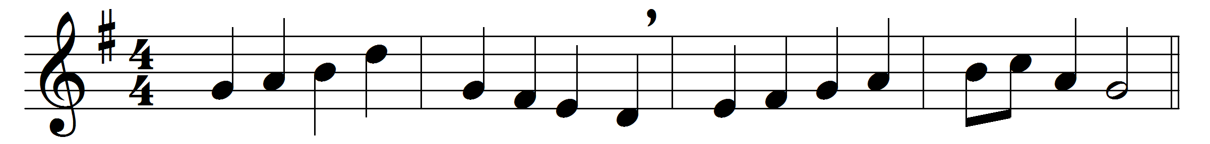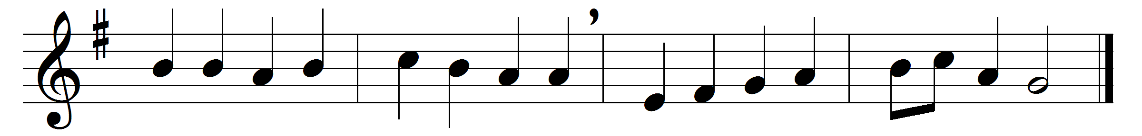

May the grace of Christ our Saviour,
and the Father’s boundless love,
with the Holy Spirit’s favour,
rest upon us from above.
Thus may we abide in union
with each other and the Lord,
and possess, in sweet communion,
joys which earth cannot afford.
Words: John Newton (1725-1807)
Music: Melody by Heinrich Albert (1604-1651), harmony adapted from Johann Sebastian Bach (1685-1750)

