Thou, whose almighty word AMNS 180 Melody: Moscow 6 6 4. 6 6 6 4.
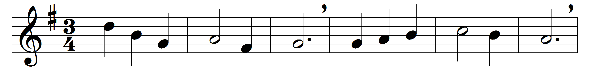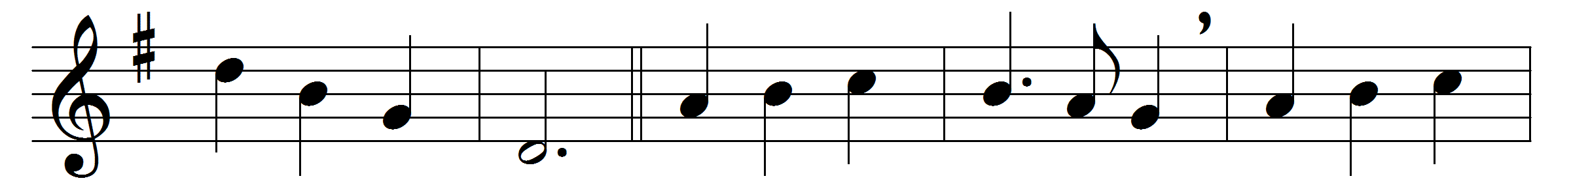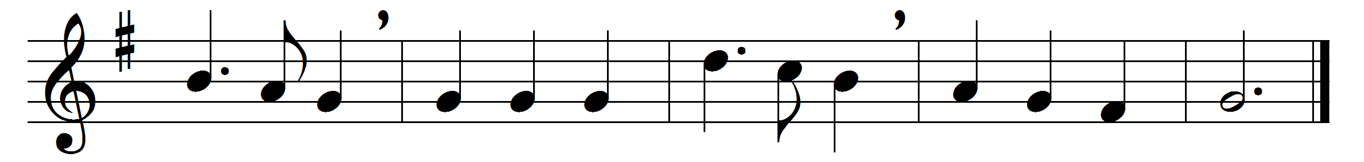

Thou, whose almighty word
chaos and darkness heard,
and took their flight;
hear us, we humbly pray,
and where the Gospel-day
sheds not its glorious ray,
let there be light.
Thou, who didst come to bring
on thy redeeming wing
healing and sight,
health to the sick in mind,
sight to the inly blind,
O now to all mankind
let there be light.
Spirit of truth and love,
life-giving, holy Dove,
speed forth thy flight;
move on the water’s face,
bearing the lamp of grace,
and in earth’s darkest place
let there be light.
Holy and blessèd Three,
glorious Trinity,
Wisdom, Love, Might;
boundless as ocean’s tide
rolling in fullest pride,
through the earth far and wide
let there be light.

Words: John Marriott (1780-1825)
Music: Felice de Giardini (1716-1796)

