Thy kingdom come! on bended knee AMNS 178 Melody: Irish C.M.
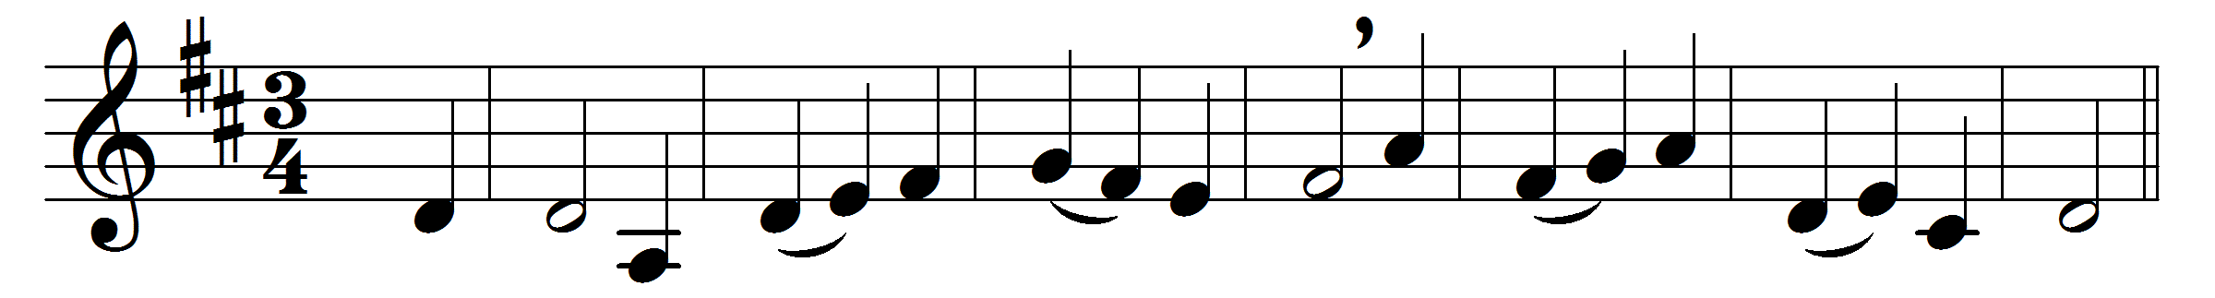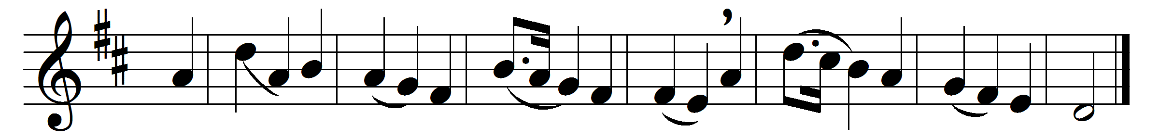

Thy kingdom come! on bended knee
the passing ages pray;
and faithful souls have yearned to see
on earth that kingdom’s day.

But the slow watches of the night
not less to God belong;
and for the everlasting right
the silent stars are strong.

And lo, already on the hills
the flags of dawn appear;
gird up your loins, ye prophet souls,
proclaim the day is near:

the day in whose clear-shining light
all wrong shall stand revealed,
when justice shall be throned in might,
and every hurt be healed;

when knowledge, hand in hand with peace,
shall walk the earth abroad:
the day of perfect righteousness,
the promised day of God.

Words: Frederick Lucian Hosmer (1840-1929)
Music: Melody from Hymns and Sacred Poems, Dublin, 1749

