Thy kingdom come, O God AMNS 177 Melody: St. Cecilia 6 6. 6 6.
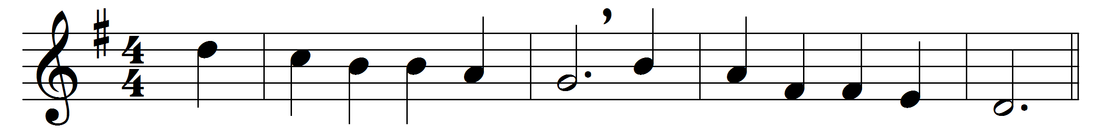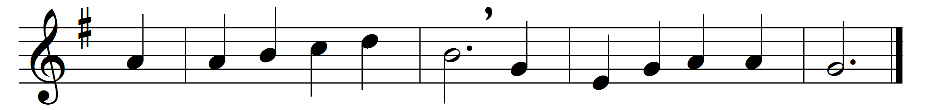

Thy kingdom come, O God,
thy rule, O Christ, begin;
break with thine iron rod
the tyrannies of sin.

Where is thy reign of peace
and purity and love?
When shall all hatred cease,
as in the realms above?

When comes the promised time
that war shall be no more,
and lust, oppression, crime
shall flee thy face before?

We pray thee, Lord, arise,
and come in thy great might;
revive our longing eyes,
which languish for thy sight.

Men scorn thy sacred name,
and wolves devour thy fold;
by many deeds of shame
we learn that love grows cold.

O’er lands both near and far
thick darkness broodeth yet:
arise, O morning star,
arise, and never set.

Words: Lewis Hensley (1824-1905)
Music: Leighton George Hayne (1836-1883)

