Happy are they, they that love God AMNS 176 Melody: Binchester C.M.
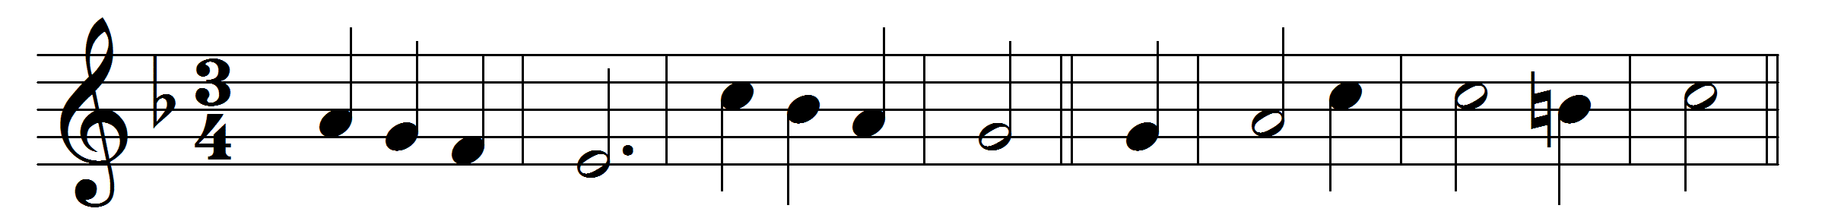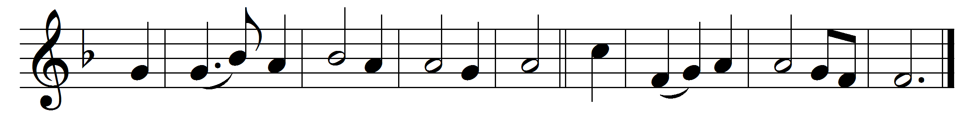

Happy are they, they that love God,
whose hearts have Christ confest,
who by his Cross have found their life,
and ’neath his yoke their rest.

Glad is the praise, sweet are the songs,
when they together sing;
and strong the prayers that bow the ear
of heaven’s eternal King.

Christ to their homes giveth his peace,
and makes their loves his own:
but ah, what tares the evil one
hath in his garden sown!

Sad were our lot, evil this earth,
did not its sorrows prove
the path whereby the sheep may find
the fold of Jesus’ love.

Then shall they know, they that love him,
how all their pain is good;
and death itself cannot unbind
their happy brotherhood.

Words: Robert Bridges (1844-1930), based on O quam juvat by Charles Coffin (1676-1749)
Music: William Croft (1678-1727)

