The heavens declare thy glory, Lord AMNS 168 Melody: Wareham L.M.
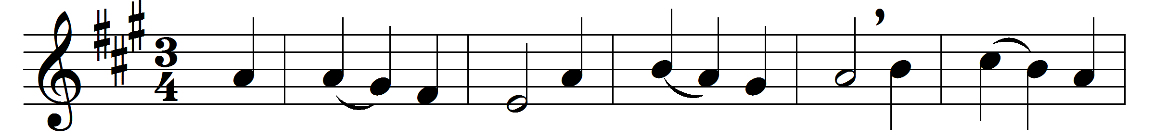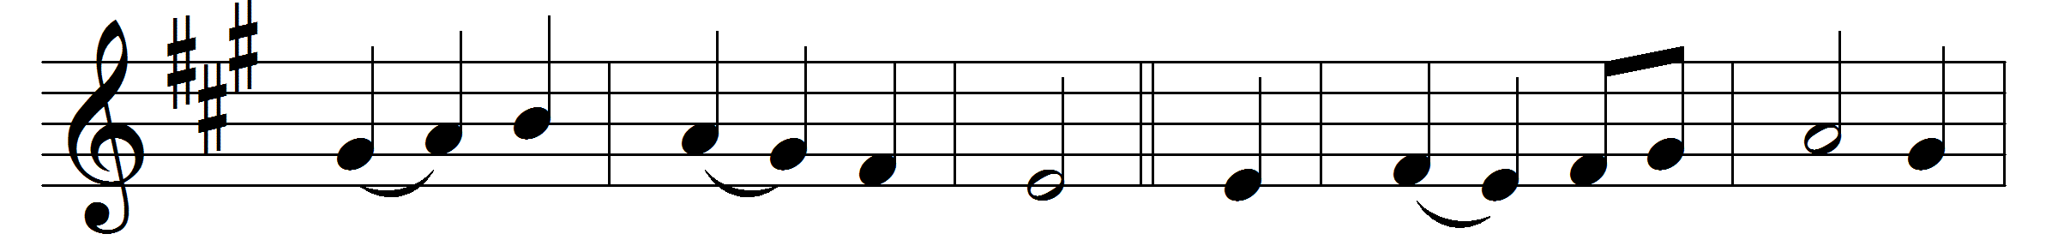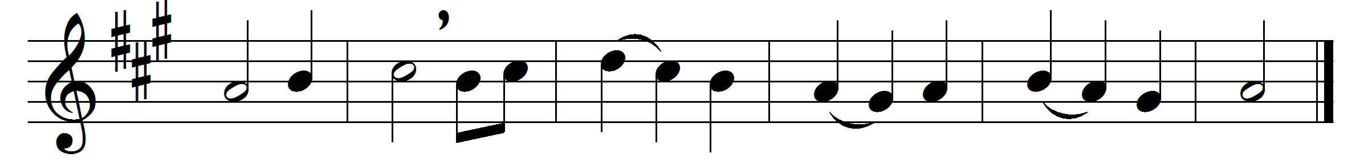

The heavens declare thy glory, Lord;
in every star thy wisdom shines;
but when our eyes behold thy word,
we read thy name in fairer lines.
Sun, moon, and stars convey thy praise
round the whole earth, and never stand;
so, when thy truth began its race,
it touched and glanced on every land.
Nor shall thy spreading Gospel rest
till through the world thy truth has run;
till Christ has all the nations blest
that see the light or feel the sun.
Great Sun of Righteousness, arise;
bless the dark world with heavenly light;
thy Gospel makes the simple wise,
thy laws are pure, thy judgements right.
Thy noblest wonders here we view,
in souls renewed and sins forgiven:
Lord, cleanse my sins, my soul renew,
and make thy word my guide to heaven.

Words: Isaac Watts (1674-1748)
Music: William Knapp (1698-1768)

