Father of mercies, in thy word AMNS 167 Melody: Angmering C.M.
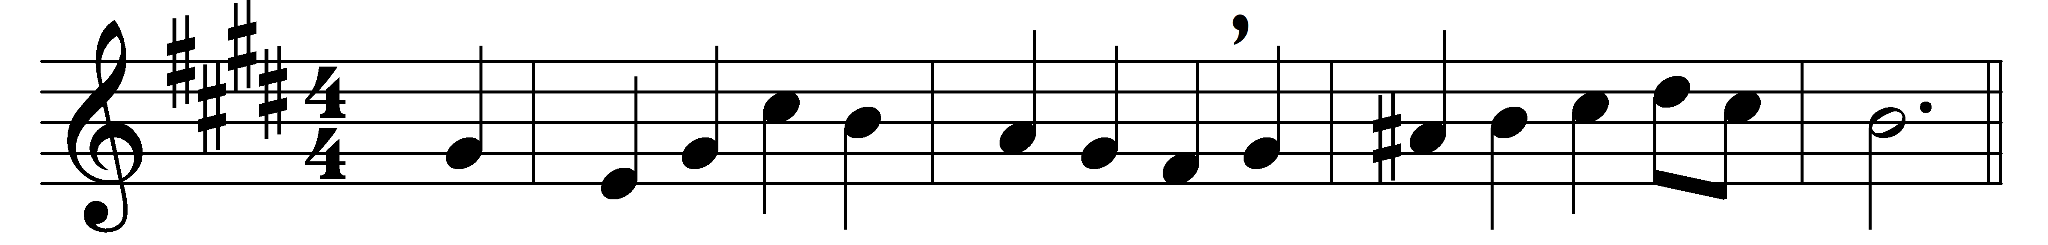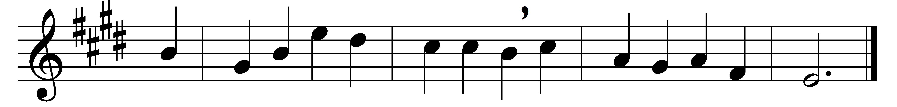

Father of mercies, in thy word
what endless glory shines!
For ever be thy name adored
for these celestial lines.

Here may the blind and hungry come,
and light and food receive;
here shall the lowliest guest have room,
and taste and see and live.

Here springs of consolation rise
to cheer the fainting mind,
and thirsting souls receive supplies,
and sweet refreshment find.

Here the Redeemer’s welcome voice
spreads heavenly peace around,
and life and everlasting joys
attend the blissful sound.

O may these hallowed pages be
my ever dear delight,
and still new beauties may I see,
and still increasing light.

Divine instructor, gracious Lord,
be thou for ever near;
teach me to love thy sacred word,
and view my Saviour here.

Words: Anne Steele (1717-1778)
Music: Charles Hubert Hastings Parry (1848-1918)

