Angel-voices ever singing AMNS 163 Melody: Angel Voices 8 5. 8 5. 8 4 3.
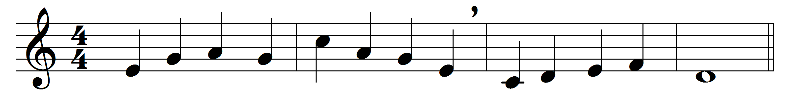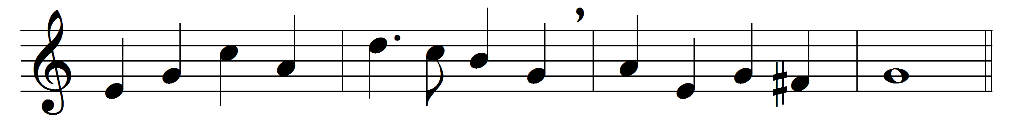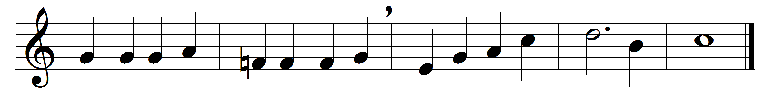

Angel-voices ever singing
round thy throne of light,
angel-harps for ever ringing,
rest not day nor night;
thousands only live to bless thee
and confess thee
Lord of might.
Thou who art beyond the farthest
mortal eye can scan,
can it be that thou regardest
songs of sinful man?
can we know that thou art near us,
and wilt hear us?
yea, we can.
Yea, we know that thou rejoicest
o'er each work of thine;
thou didst ears and hands and voices
for thy praise design;
craftsman’s art and music’s measure
for thy pleasure
all combine.
In thy house, great God, we offer
of thine own to thee;
and for thine acceptance proffer
all unworthily
hearts and minds and hands and voices
in our choicest
psalmody.
Honour, glory, might, and merit
thine shall ever be,
Father, Son, and Holy Spirit,
blessèd Trinity.
Of the best that thou hast given
earth and heaven
render thee.

Words: Francis Pott (1832-1909)
Music: Edwin George Monk (1819-1900)

