Jesus, where’er thy people meet AMNS 162 Melody: Wareham L.M.
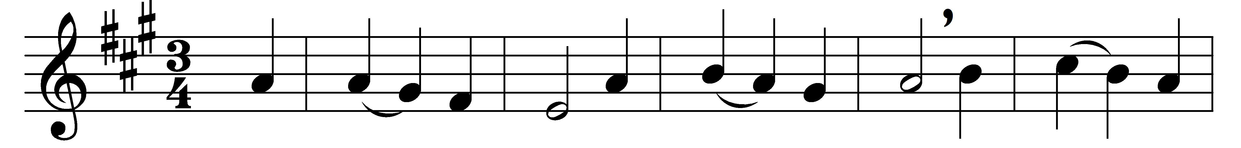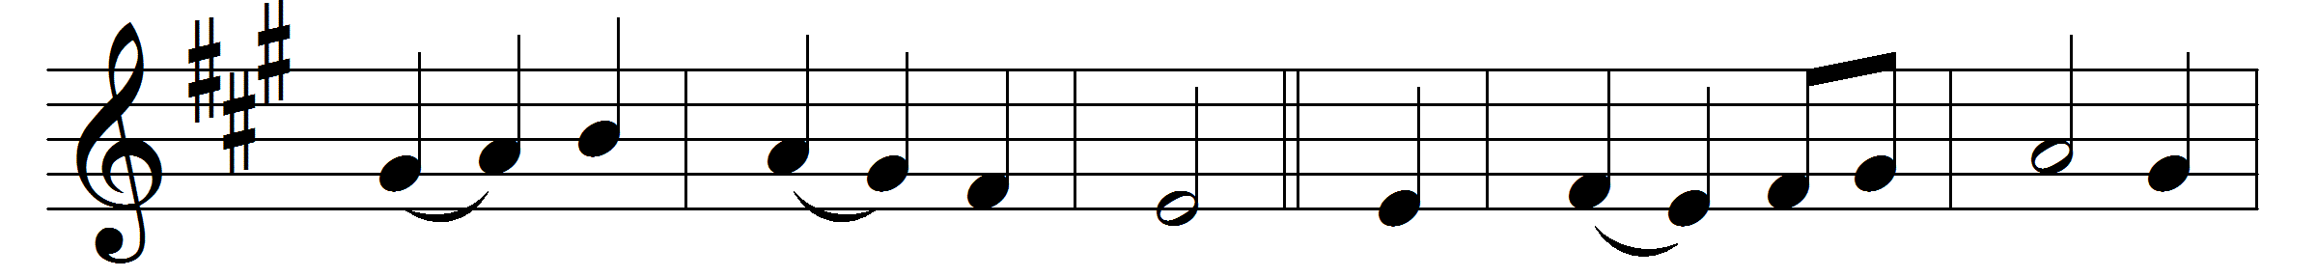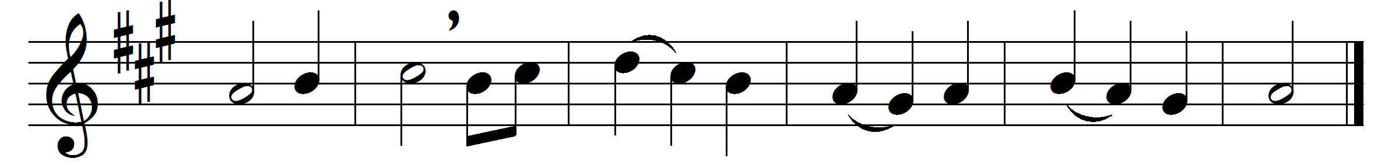

Jesus, where’er thy people meet,
there they behold thy mercy-seat;
where’er they seek thee thou art found,
and every place is hallowed ground.

For thou, within no walls confined,
inhabitest the humble mind;
such ever bring thee when they come,
and, going, take thee to their home.

Dear Shepherd of thy chosen few,
thy former mercies here renew;
here to our waiting hearts proclaim
the sweetness of thy saving name.

Here may we prove the power of prayer
to strengthen faith and sweeten care,
to teach our faint desires to rise,
and bring all heaven before our eyes.

Lord, we are few, but thou art near;
nor short thine arm, nor deaf thine ear:
O rend the heavens, come quickly down,
and make a thousand hearts thine own.

Words: William Cowper (1731-1800)
Melody: William Knapp (1698-1768)

