We love the place, O God AMNS 160 Melody: Quam Dilecta 6. 6. 6. 6.
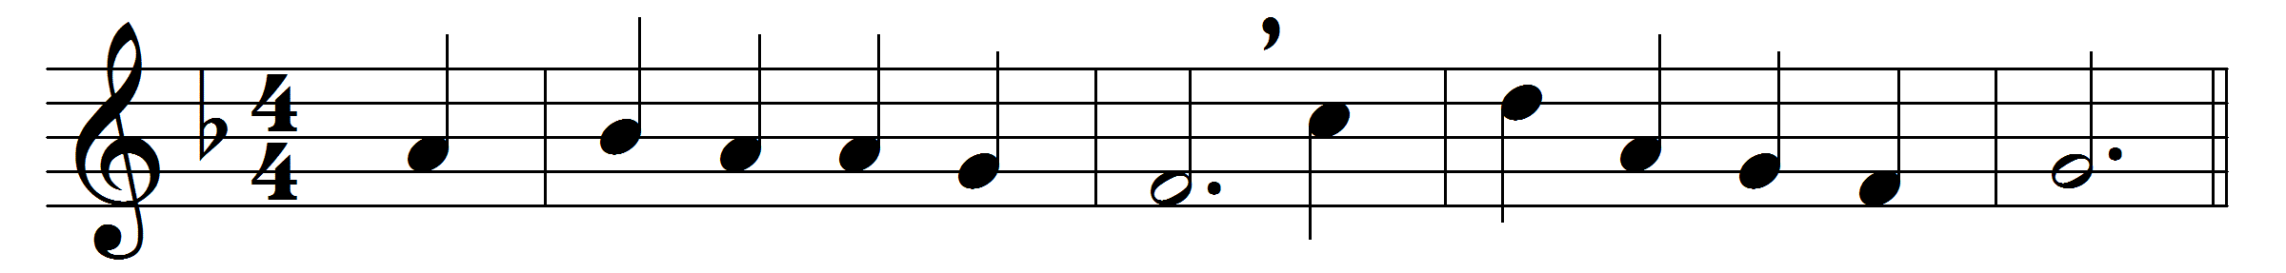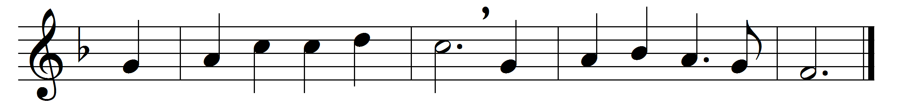

We love the place, O God,
wherein thine honour dwells;
the joy of thine abode
all earthly joy excels.

It is the house of prayer,
wherein thy servants meet;
and thou, O Lord, art there
thy chosen flock to greet.

We love the sacred font;
for there the holy Dove
to pour is ever wont
his blessing from above.

We love thine altar, Lord;
O what on earth so dear?
for there, in faith adored,
we find thy presence near.

We love the word of life,
the word that tells of peace,
of comfort in the strife,
and joys that never cease.

We love to sing below
for mercies freely given;
but O, we long to know
the triumph-song of heaven.

Lord Jesus, give us grace
on earth to love thee more,
in heaven to see thy face,
and with thy saints adore.

Words: William Bullock (1798-1874) and Henry Williams Baker (1821-1877)
Music: Henry Lascelles Jenner (1820-1898)

