Love of the Father, Love of God the Son AMNS 159 Melody: Song 22 10. 10. 10. 10.
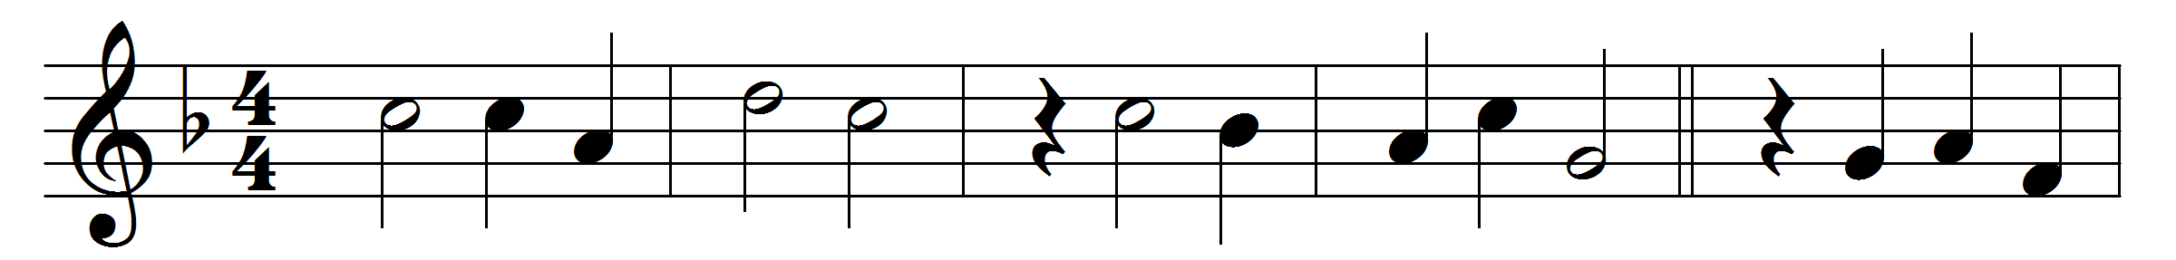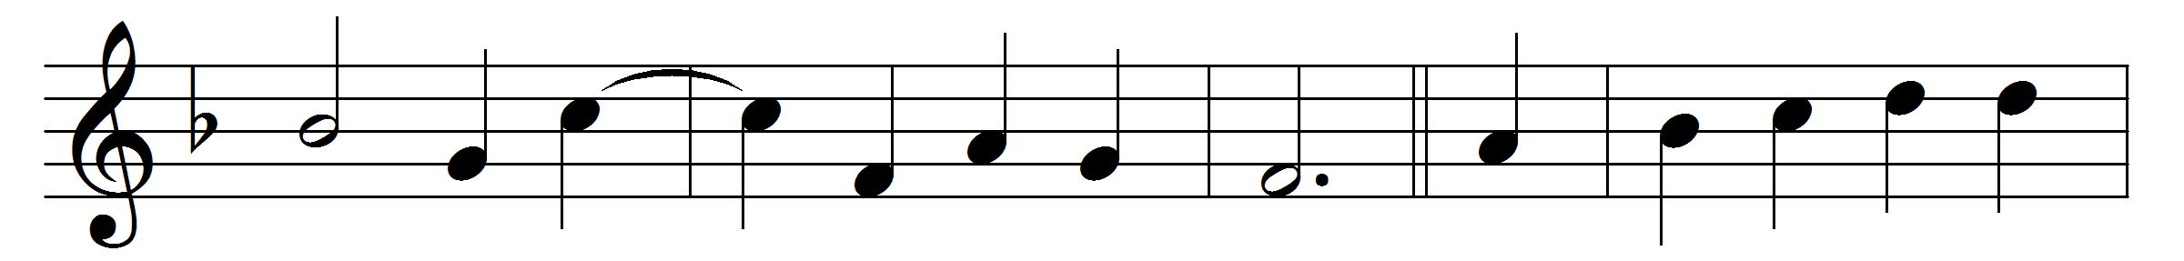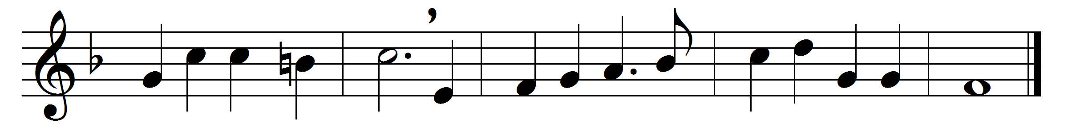

Love of the Father, Love of God the Son,
from whom all came, in whom was all begun;
who formest heavenly beauty out of strife,
creation’s whole desire and breath of life:
Thou the all-holy, thou supreme in might,
thou dost give peace, thy presence maketh right;
thou with thy favour all things dost enfold,
with thine all-kindness free from harm wilt hold.
Hope of all comfort, splendour of all aid,
that dost not fail nor leave the heart afraid:
to all that cry thou dost all help accord,
the angels’ armour, and the saints’ reward.
Purest and highest, wisest and most just,
there is no truth save only in thy trust;
thou dost the mind from earthly dreams recall,
and bring, through Christ, to him for whom are all.
Eternal glory, all men thee adore,
who art and shalt be worshipped evermore:
us whom thou madest, comfort with thy might,
and lead us to enjoy thy heavenly light.

Words: Robert Bridges (1844-1930), based on Amor Patris et Filii, 12th century
Music: Melody and bass by Orlando Gibbons (1583-1625)

