O Holy Ghost, thy people bless AMNS 155 Melody: St. Timothy C.M.
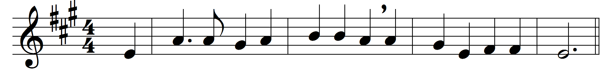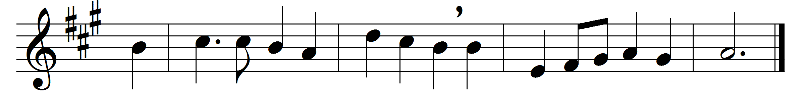

O Holy Ghost, thy people bless
who long to feel thy might,
and fain would grow in holiness
as children of the light.
To thee we bring, who art the Lord,
our selves to be thy throne;
let every thought and deed and word
thy pure dominion own.
Life-giving Spirit, o’er us move,
as on the formless deep;
give life and order, light and love,
where now is death or sleep.
Great gift of our ascended King,
his saving truth reveal;
our tongues inspire his praise to sing,
our hearts his love to feel.
True wind of heaven, from south or north,
for joy or chastening, blow;
the garden-spices shall spring forth
if thou wilt bid them flow.
O Holy Ghost, of sevenfold might,
all graces come from thee;
grant us to know and serve aright
One God in Persons Three.

Words and music: Henry Williams Baker (1821-1877)

