Gracious Spirit, Holy Ghost AMNS 154 Melody: Charity 7. 7. 7. 5.
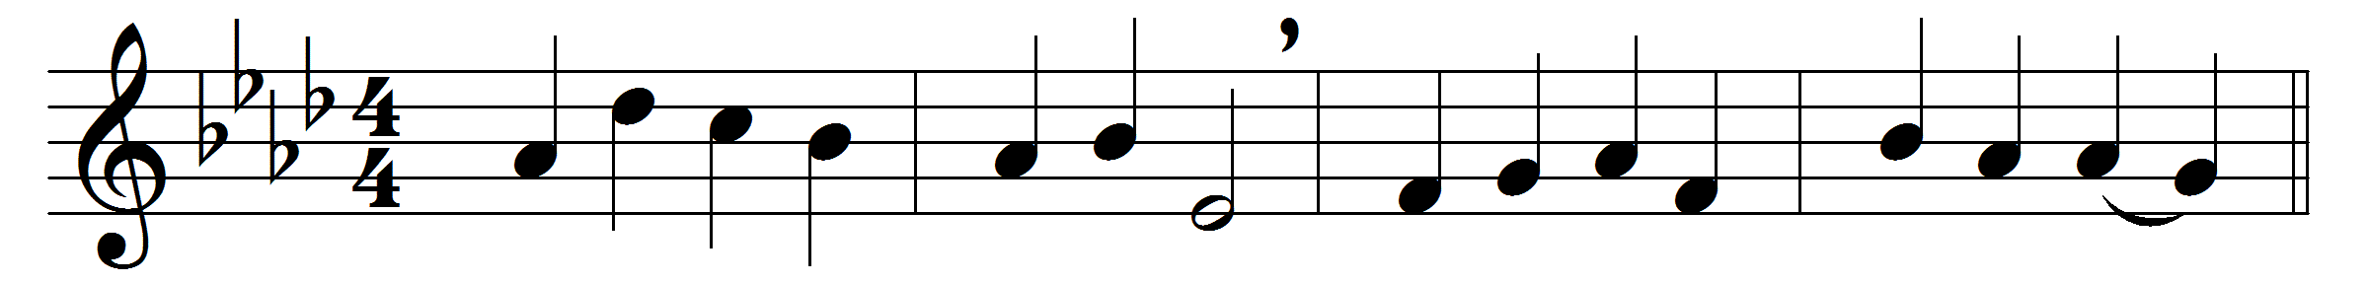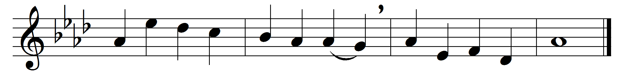

Gracious Spirit, Holy Ghost,
taught by thee, we covet most
of thy gifts at Pentecost,
holy, heavenly love.

Love is kind, and suffers long,
love is meek, and thinks no wrong,
love than death itself more strong;
therefore give us love.

Prophecy will fade away,
melting in the light of day;
love will ever with us stay;
therefore give us love.

Faith will vanish into sight;
hope be emptied in delight;
love in heaven will shine more bright;
therefore give us love.

Faith and hope and love we see
joining hand in hand agree;
but the greatest of the three,
and the best, is love.

From the overshadowing
of thy gold and silver wing
shed on us, who to thee sing,
holy, heavenly love.

Words: Christopher Wordsworth (1807-1885)
Music: John Stainer (1840-1901)

