O Holy Spirit, Lord of grace AMNS 152 Melody: Tallis’s Ordinal C.M.
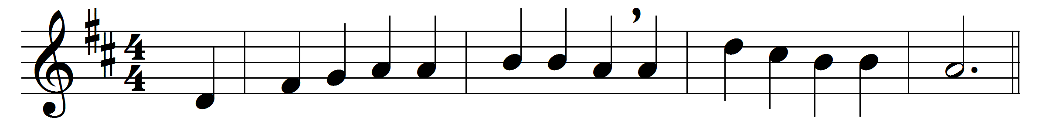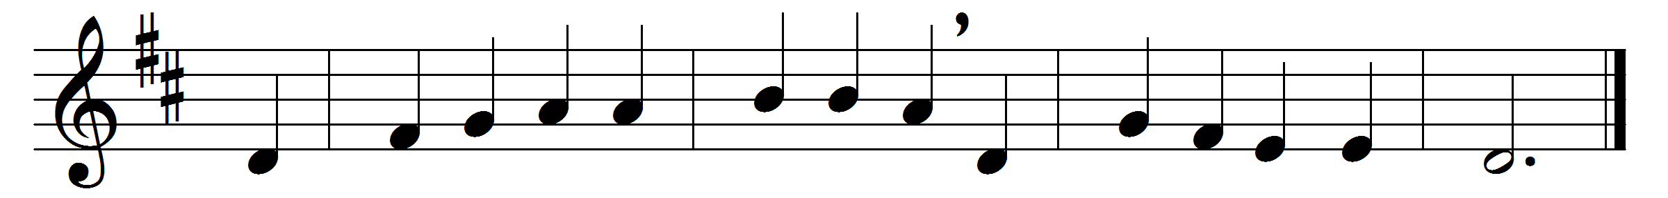

O Holy Spirit, Lord of grace,
eternal fount of love,
inflame, we pray, our inmost hearts
with fire from heaven above.
As thou in bond of love dost join
the Father and the Son,
so fill us all with mutual love,
and knit our hearts in one.
All glory to the Father be,
all glory to the Son,
all glory, Holy Ghost, to thee,
while endless ages run.

Words: Charles Coffin (1676-1749), translated by John Chandler (1808-1876)
Music: Thomas Tallis (c. 1505-1585)

