Our blest Redeemer, ere he breathed AMNS 151 Melody: St. Cuthbert 8. 6. 8. 4.
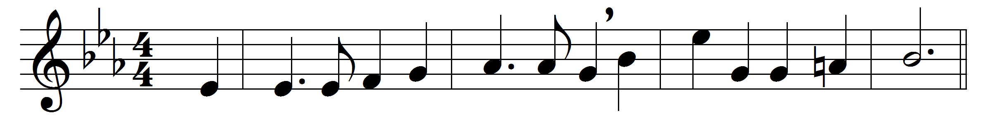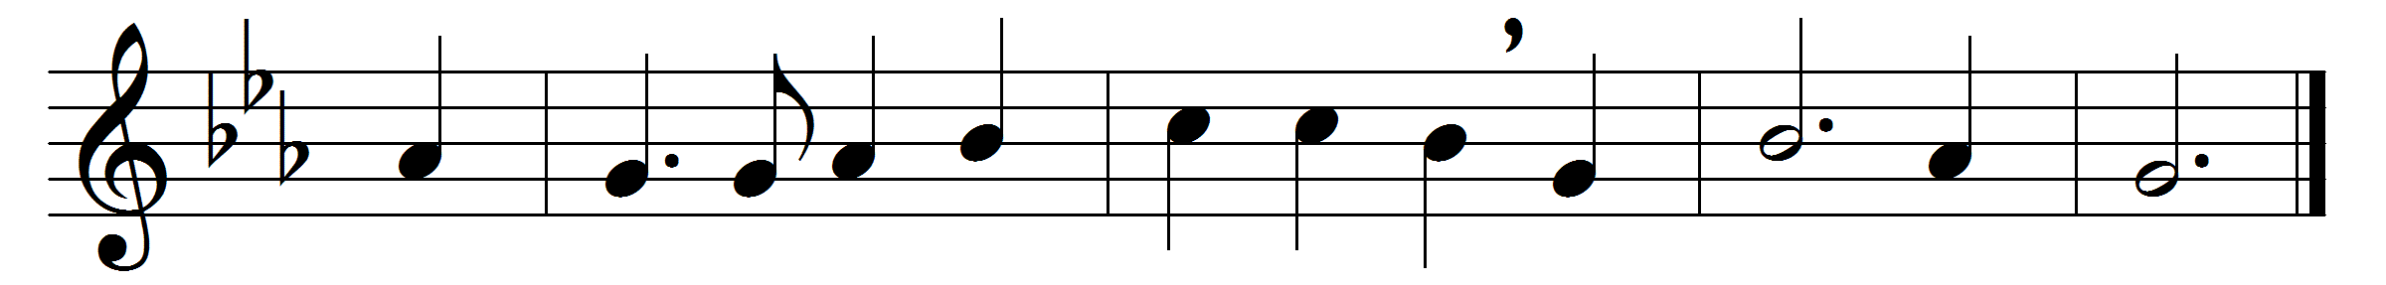

Our blest Redeemer, ere he breathed
his tender last farewell,
a Guide, a Comforter, bequeathed
with us to dwell.
He came sweet influence to impart,
a gracious willing guest,
while he can find one humble heart
wherein to rest.
And his that gentle voice we hear,
soft as the breath of even,
that checks each fault, that calms each fear,
and speaks of heaven.
And every virtue we possess,
and every conquest won,
and every thought of holiness,
are his alone.
Spirit of purity and grace,
our weakness, pitying, see:
O make our hearts thy dwelling-place,
and worthier thee.

Words: Harriet Auber (1773-1862)
Music: John Bacchus Dykes (1823-1876)

