The sun is sinking fast AMNS 14 Melody: St. Columba 6 4. 6 6.
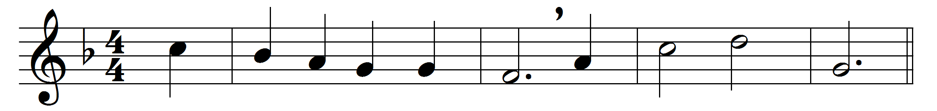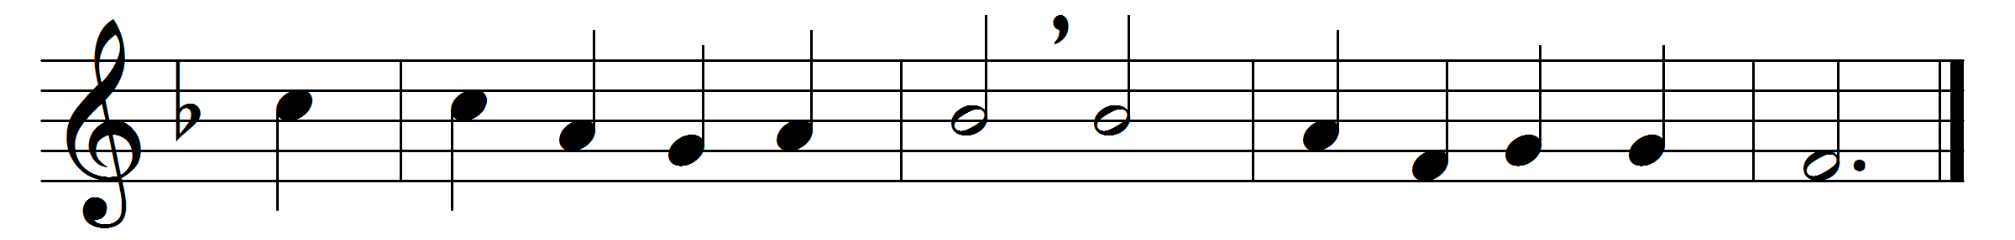

The sun is sinking fast,
the daylight dies;
let love awake, and pay
her evening sacrifice.
As Christ upon the cross
his head inclined,
and to his Father’s hands
his parting soul resigned,
so now herself my soul
would wholly give
into his sacred charge,
in whom all spirits live;
so now beneath his eye
would calmly rest,
without a wish or thought
abiding in the breast,
save that his will be done,
whate’er betide,
dead to herself, and dead
in him to all beside.
Thus would I live; yet now
not I, but he,
in all his power and love
henceforth alive in me.
One sacred Trinity,
one Lord divine,
may I be ever his,
and he for ever mine.

Words: Latin, c. 18th century, translated by Edward Caswall (1814-1878)
Music: Herbert Stephen Irons (1834-1905)

