Come, ye faithful, raise the anthem AMNS 145 Melody: Neander (Unser Herrscher) 8 7. 8 7. 8 7.
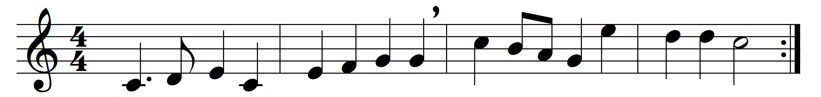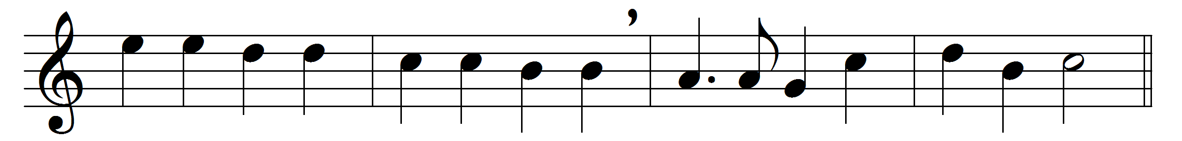

Come, ye faithful, raise the anthem,
cleave the skies with shouts of praise;
sing to him who found the ransom,
Ancient of eternal days,
God of God, the Word incarnate,
whom the heaven of heaven obeys.
Ere he raised the lofty mountains,
formed the seas, or built the sky,
love eternal, free, and boundless,
moved the Lord of life to die,
fore-ordained the Prince of princes
for the throne of Calvary.
There, for us and our redemption,
see him all his life-blood pour!
there he wins our full salvation,
dies that we may die no more;
then, arising, lives for ever,
reigning where he was before.
High on yon celestial mountains
stands his sapphire throne, all bright,
midst unending alleluias
bursting from the sons of light;
Sion’s people tell his praises,
victor after hard-won fight.
Bring your harps, and bring your incense,
sweep the string and pour the lay;
let the earth proclaim his wonders,
King of that celestial day;
he the Lamb once slain is worthy,
who was dead, and lives for ay.
Laud and honour to the Father,
laud and honour to the Son,
laud and honour to the Spirit,
ever Three and ever One,
consubstantial, co-eternal,
while unending ages run.

Words: Job Hupton (1762-1849) and John Mason Neale (1818-1866)
Melody: Joachim Neander (1640-1680)

