Come, let us join our cheerful songs AMNS 144 Melody: Nativity C.M.
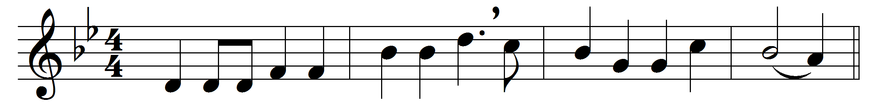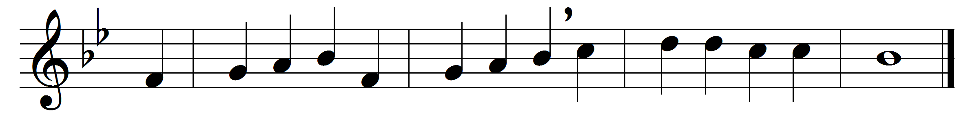

Come, let us join our cheerful songs
with angels round the throne;
ten thousand thousand are their tongues,
but all their joys are one.

‘Worthy the Lamb that died,’ they cry,
‘to be exalted thus;’
‘worthy the Lamb,’ our lips reply,
‘for he was slain for us.’

Jesus is worthy to receive
honour and power divine;
and blessings, more than we can give,
be, Lord, for ever thine.

Let all creation join in one
to bless the sacred name
of him that sits upon the throne,
and to adore the Lamb.

Words: Isaac Watts (1674-1748)
Melody: Henry Lahee (1826-1912)

