Hail to the Lord’s Anointed AMNS 142 Melody: Crüger 7 6. 7 6. D.
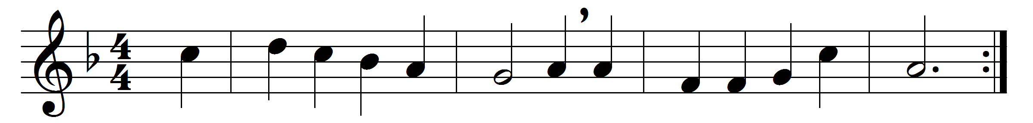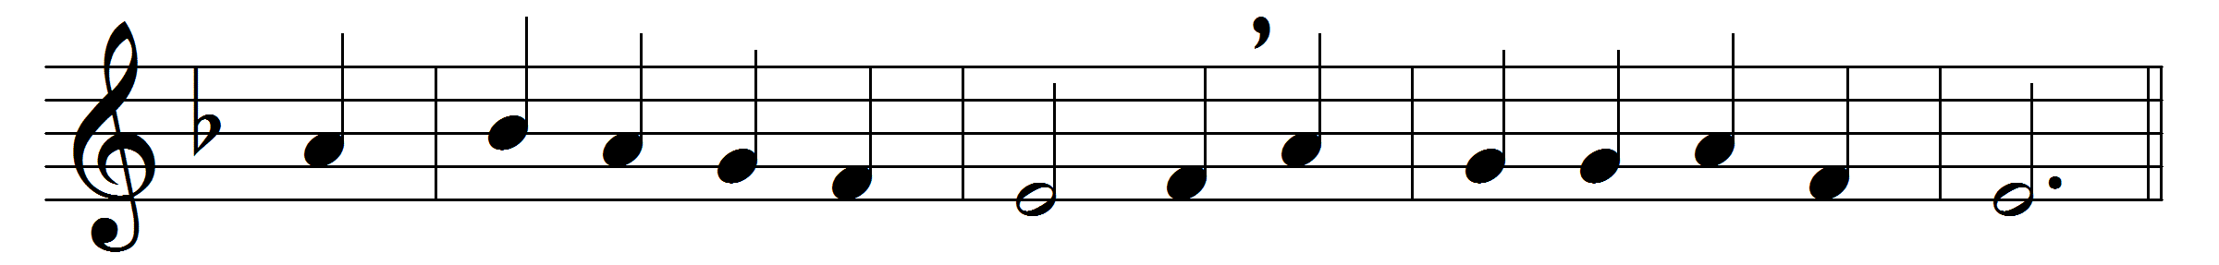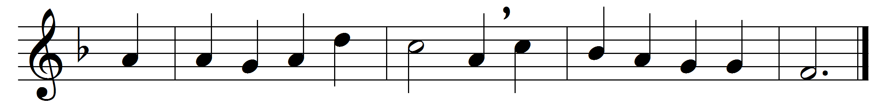

Hail to the Lord’s Anointed,
great David’s greater Son!
Hail, in the time appointed,
his reign on earth begun!
He comes to break oppression,
to set the captive free,
to take away transgression,
and rule in equity.
He comes with succour speedy
to those who suffer wrong;
to help the poor and needy,
and bid the weak be strong;
to give them songs for sighing,
their darkness turn to light,
whose souls, condemned and dying,
were precious in his sight.
He shall come down like showers
upon the fruitful earth,
and love, joy, hope, like flowers,
spring in his path to birth:
before him on the mountains
shall peace, the herald, go;
and righteousness in fountains
from hill to valley flow.
Arabia’s desert-ranger
to him shall bow the knee;
the Ethiopian stranger
his glory come to see;
with offerings of devotion
ships from the isles shall meet,
to pour the wealth of ocean
in tribute at his feet.
Kings shall bow down before him,
and gold and incense bring;
all nations shall adore him,
his praise all people sing:
to him shall prayer unceasing
and daily vows ascend;
his kingdom still increasing,
a kingdom without end.
O’er every foe victorious,
he on his throne shall rest;
from age to age more glorious,
all-blessing and all-blest:
the tide of time shall never
his covenant remove;
his name shall stand for ever,
his changeless name of love.

Words: James Montgomery (1771-1854)
Music: Adapted from Johann Crüger (1598-1662) by William Henry Monk (1823-1889)

