The head that once was crowned with thorns AMNS 141 Melody: St. Magnus C.M.
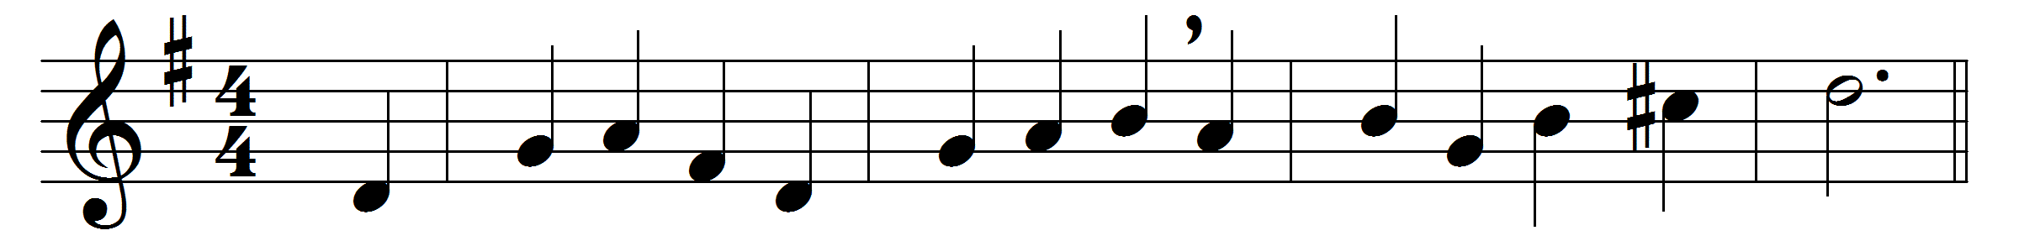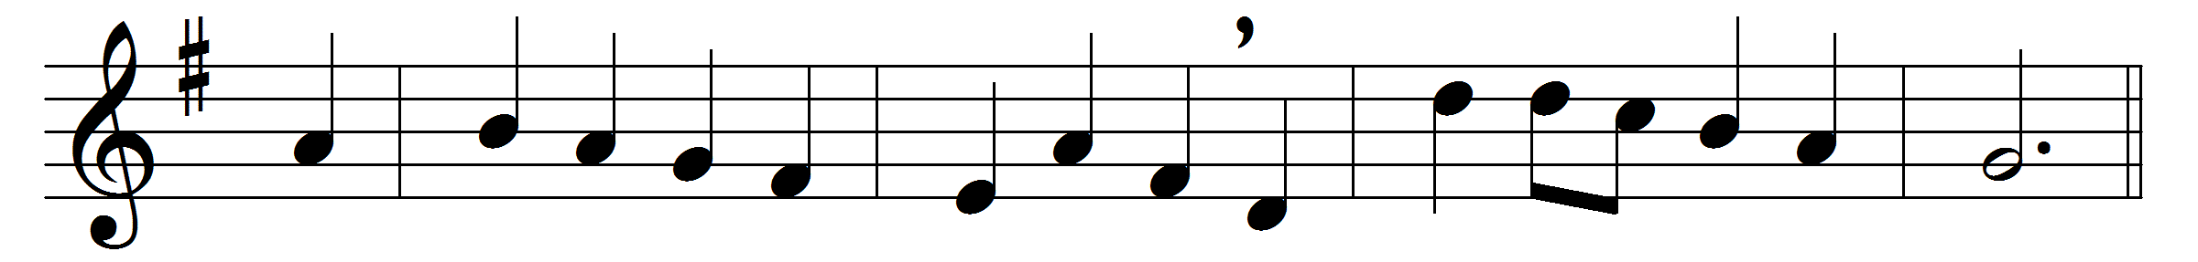

The head that once was crowned with thorns
is crowned with glory now:
a royal diadem adorns
the mighty Victor’s brow.
The highest place that heaven affords
is his, is his by right,
the King of kings, and Lord of lords,
and heaven’s eternal Light;
the joy of all who dwell above,
the joy of all below,
to whom he manifests his love,
and grants his name to know.
To them the Cross, with all its shame,
with all its grace, is given:
their name an everlasting name,
their joy the joy of heaven.
They suffer with their Lord below,
they reign with him above;
their profit and their joy to know
the mystery of his love.
The Cross he bore is life and health,
though shame and death to him;
his people’s hope, his people’s wealth,
their everlasting theme.

Words: Thomas Kelly (1769-1855)
Music: Jeremiah Clarke (c. 1673-1707)

