Abide with me; fast falls the eventide AMNS 13 Melody: Eventide 10 10. 10 10.
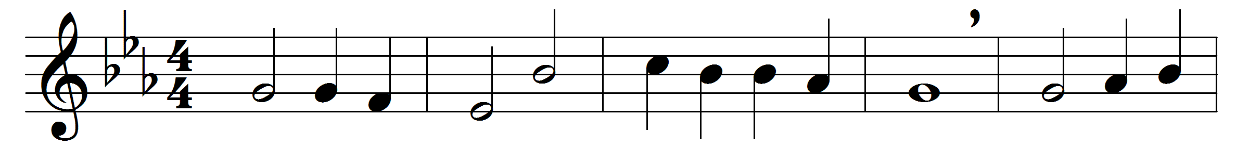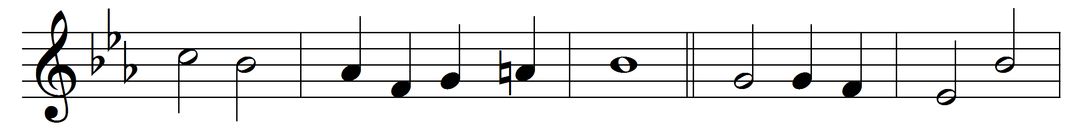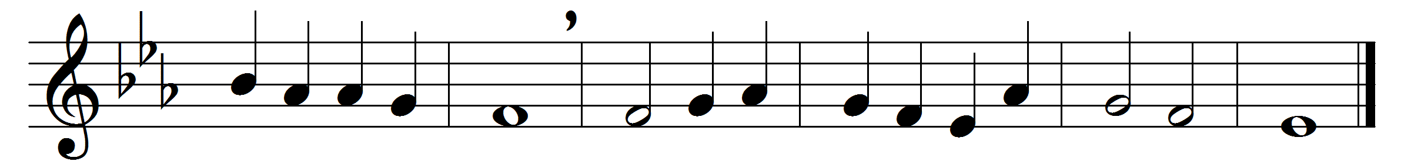

Abide with me; fast falls the eventide:
the darkness deepens; Lord, with me abide:
when other helpers fail, and comforts flee,
help of the helpless, O abide with me.
Swift to its close ebbs out life’s little day;
earth’s joys grow dim, its glories pass away;
change and decay in all around I see:
O thou who changest not, abide with me.
I need thy presence every passing hour;
what but thy grace can foil the tempter’s power?
Who like thyself my guide and stay can be?
Through cloud and sunshine, Lord, abide with me.
I fear no foe with thee at hand to bless;
ills have no weight, and tears no bitterness.
Where is death’s sting? Where, grave, thy victory?
I triumph still, if thou abide with me.
Hold thou thy cross before my closing eyes;
shine through the gloom, and point me to the skies:
heaven’s morning breaks, and earth’s vain shadows flee;
in life, in death, O Lord, abide with me.

Words: Henry Francis Lyte (1793-1847)
Music: William Henry Monk (1823-1889)

