Rejoice! the Lord is King AMNS 139 Melody: Gopsal 6 6. 6 6. 8 8.
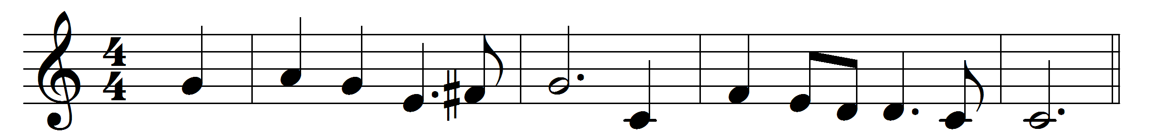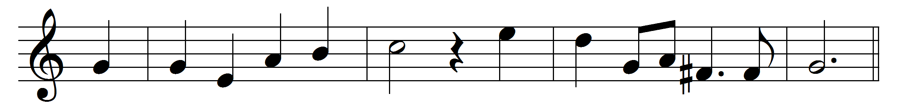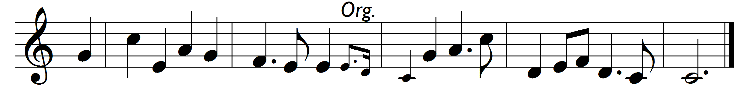

Rejoice! the Lord is King.
Your Lord and King adore;
mortals, give thanks and sing,
and triumph evermore:
Refrain: lift up your heart, lift up your voice;
rejoice, again I say, rejoice.
Jesus, the Saviour, reigns,
the God of truth and love;
when he had purged our stains,
he took his seat above:
Refrain
His kingdom cannot fail;
he rules o’er earth and heaven;
the keys of death and hell
are to our Jesus given:
Refrain
He sits at God’s right hand
till all his foes submit,
and bow to his command,
and fall beneath his feet:
Refrain

Words: Charles Wesley (1707-1788)
Music: Melody and figured bass by George Frederick Handel (1685-1759)

