We sing the praise of him who died AMNS 138 Melody: Breslau L.M.
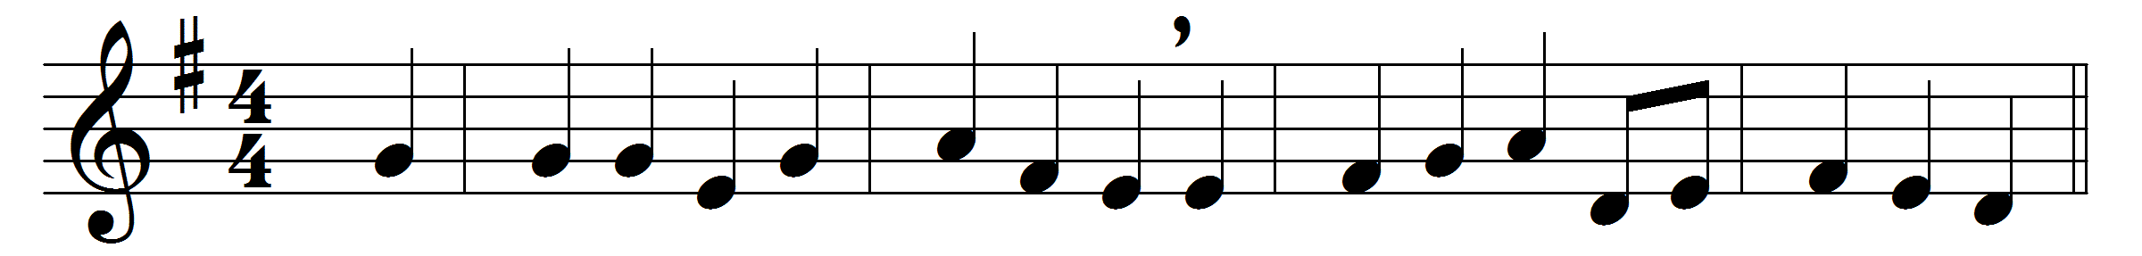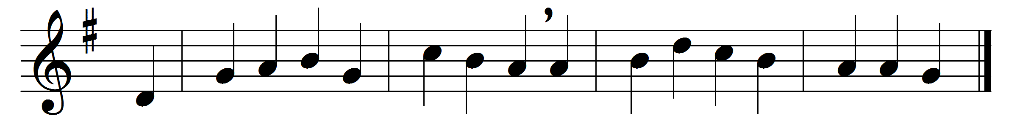

We sing the praise of him who died,
of him who died upon the cross;
the sinner’s hope let men deride,
for this we count the world but loss.
Inscribed upon the cross we see
in shining letters, ‘God is love’;
he bears our sins upon the Tree;
he brings us mercy from above.
The Cross! it takes our guilt away:
it holds the fainting spirit up;
it cheers with hope the gloomy day,
and sweetens every bitter cup.
It makes the coward spirit brave,
and nerves the feeble arm for fight;
it takes its terror from the grave,
and gilds the bed of death with light:
the balm of life, the cure of woe,
the measure and the pledge of love,
the sinner’s refuge here below,
the angels’ theme in heaven above.

Words: Thomas Kelly (1769-1855)
Music: German traditional melody as used by Felix Mendelssohn-Bartholdy (1809-1847)

