There is a green hill far away AMNS 137 Melody: Horsley C.M.
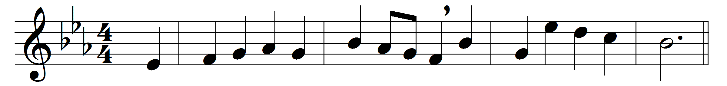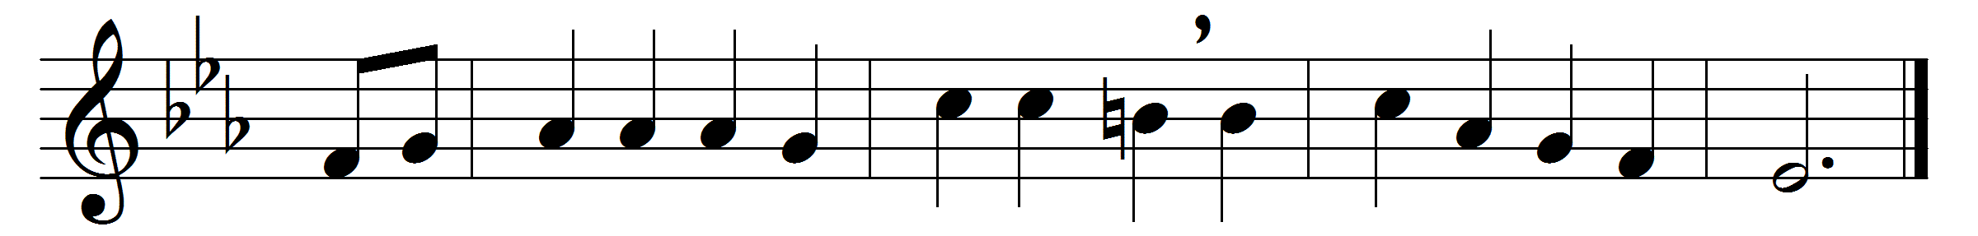

There is a green hill far away,
without a city wall,
where the dear Lord was crucified,
who died to save us all.
We may not know, we cannot tell,
what pains he had to bear,
but we believe it was for us
he hung and suffered there.
He died that we might be forgiven,
he died to make us good,
that we might go at last to heaven,
saved by his precious blood.
There was no other good enough
to pay the price of sin;
he only could unlock the gate
of heaven, and let us in.
O dearly, dearly has he loved,
and we must love him too,
and trust in his redeeming blood,
and try his works to do.

Words: Cecil Frances Alexander (1818-1895)
Music: William Horsley (1774-1858)

